# INDEX

|  |  |  |  |
| --- | --- | --- | --- |
| Sr.No | Name | Date | Sign. |
| 1. | Implement vmwareESXi for server virtualization |  |  |
| 2. | Implement XEN for server virtualization |  |  |
| 3. | Implement Hyper-V server virtualization |  |  |
| 4. | Manage vmwareESXi with vCentre server |  |  |
| 5. | Manage xen server Xencentre |  |  |
| 6. | Understanding blade server with cisco UCS/HP eva simulator |  |  |
| 7. | Implement vlan concept with L2/L3 switches/nexus virtual switching |  |  |
| 8. | Simulating SAN with navisphere/netapps |  |  |

# Practical No 1

Implement vmwareESXi for server virtualization

• Boot your Host from the CD, and then select the standard installer option

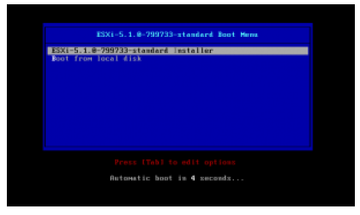

You will see the following screen’s as it goes through its boot process.

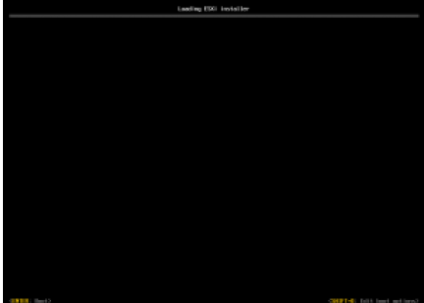

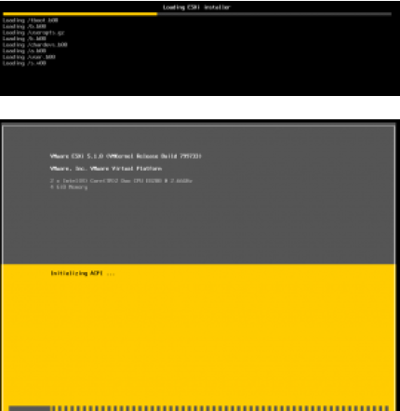

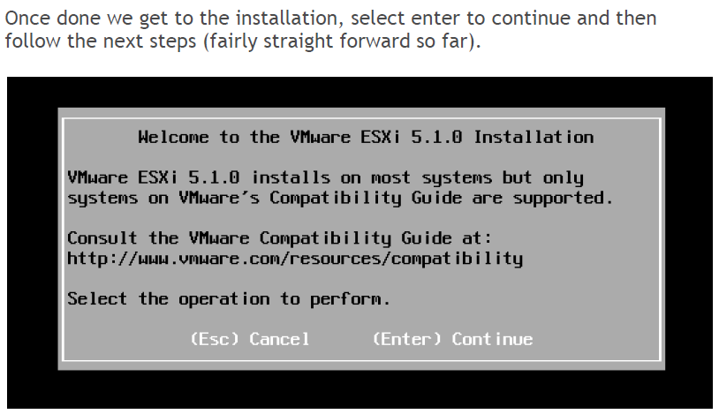

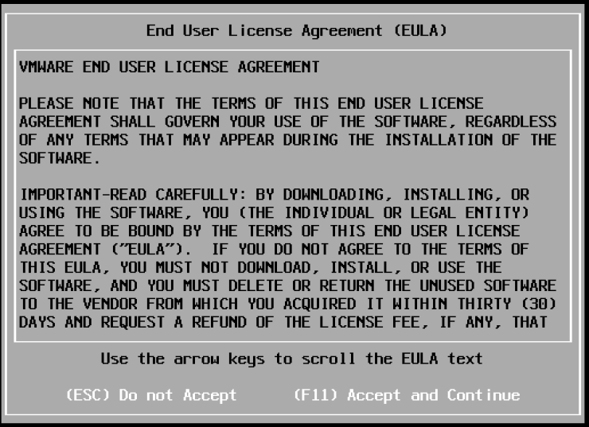

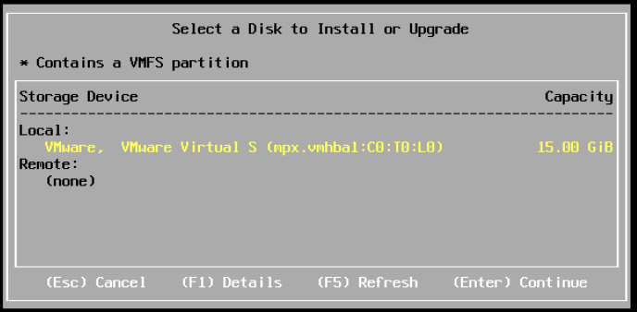

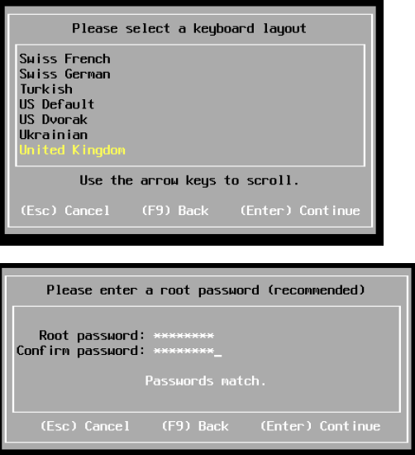

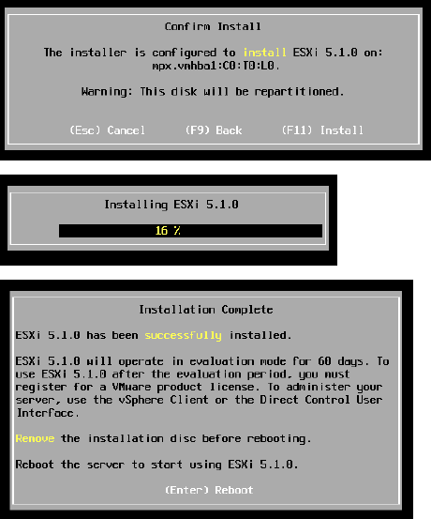

Now we have installed ESXi (didn’t take that long did it!? How long did you think it would take?), if we reboot the host will then come up and load the ESXi OS.

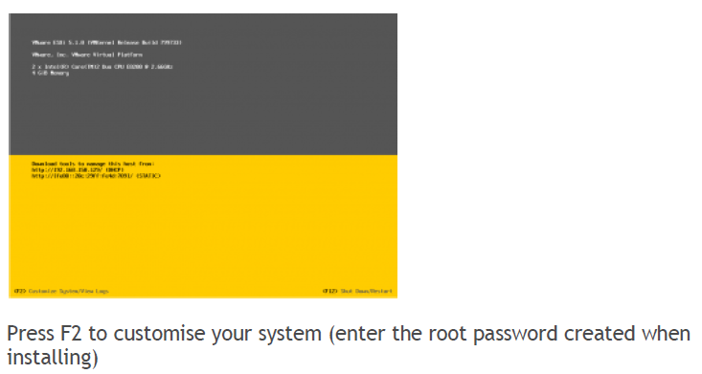

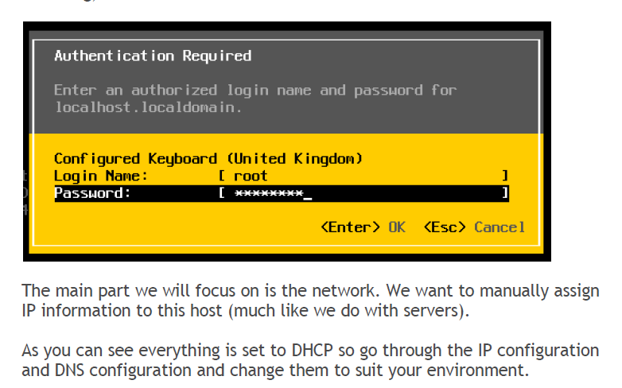

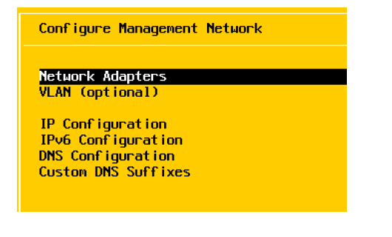

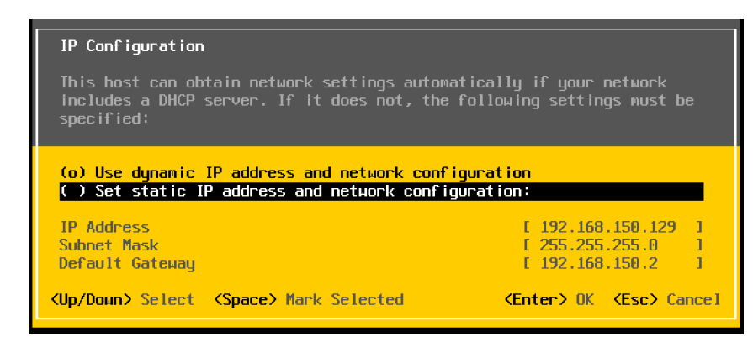

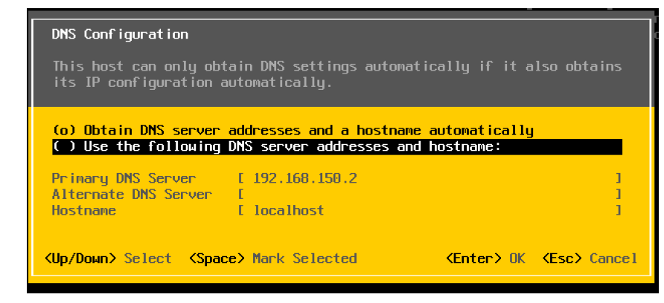Once done, it will ask you to save changes and restart the network management of the ESXi host. Confirm this and now we can leave this underlying OS behind.

• Download VSphere Client.

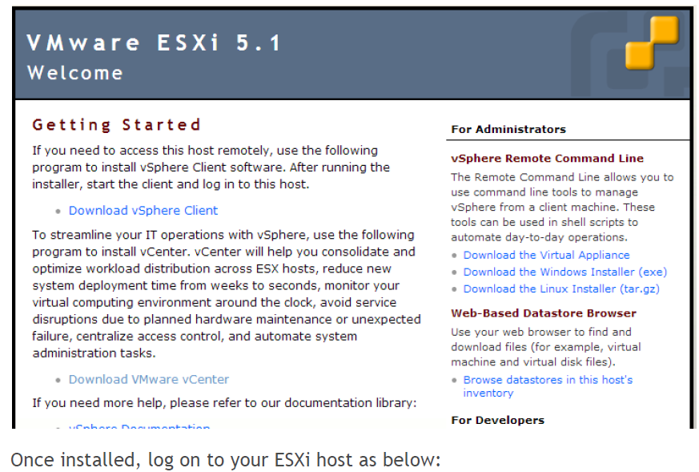

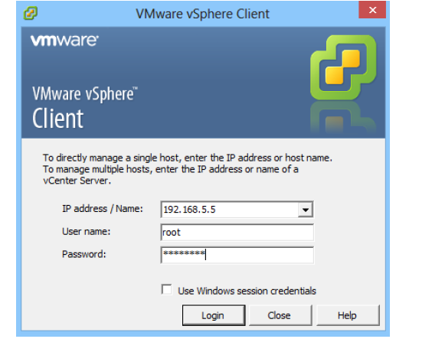We are now going to create our first virtual machine (and in this example it’s going to be the VMWareVcenter Server).

Right click the host, and select New Virtual Machine (it’s a standard next, next, next, finish dialogue box), just change any details you require as the screen shots below

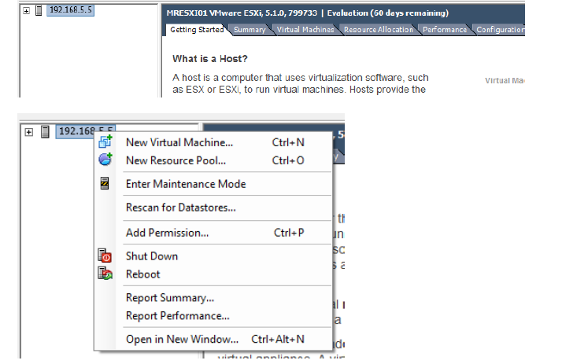

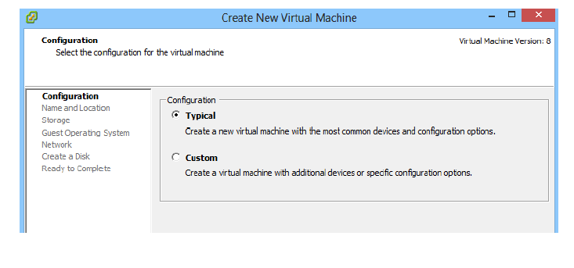

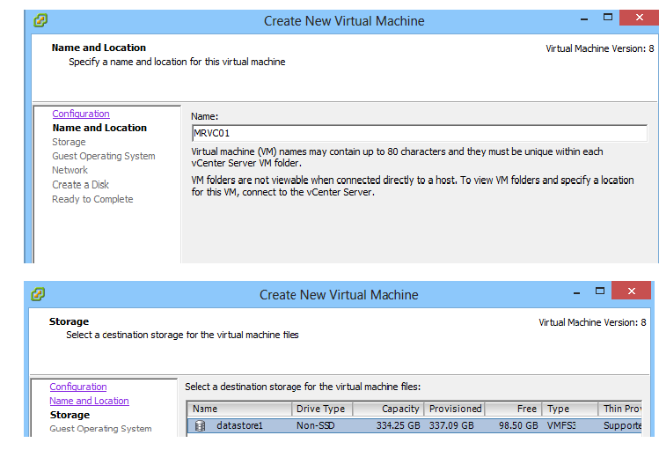

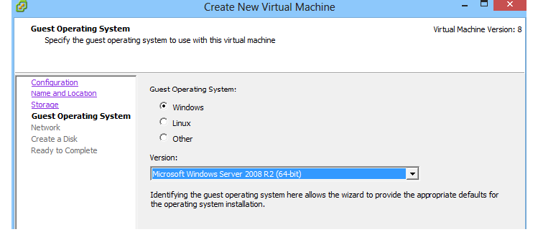

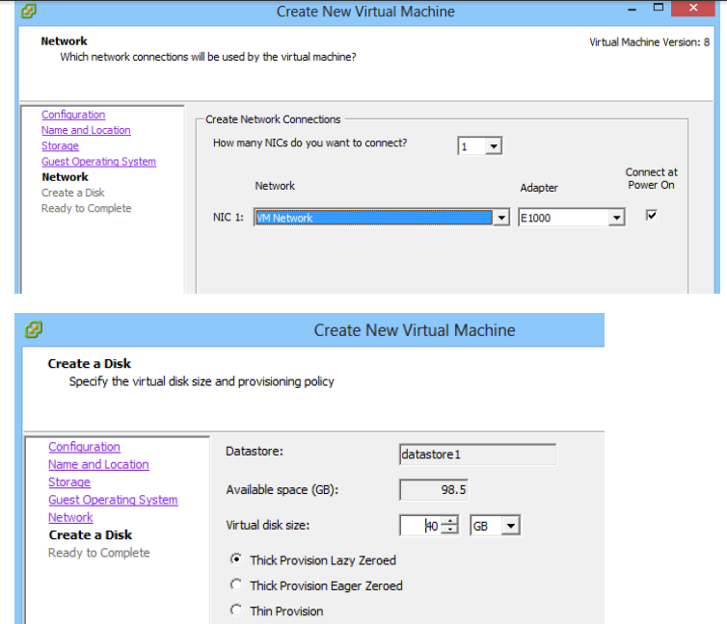

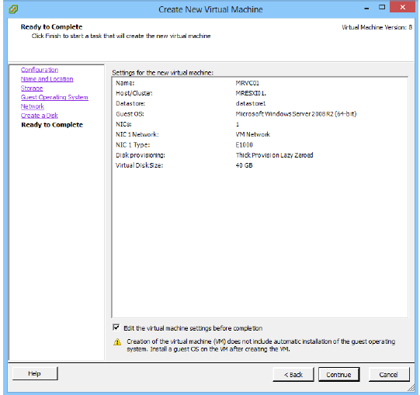

I always like to edit the virtual machine before completion (tick box at the bottom).

The reason for this is:

1. I remove the floppy drive

2. I give the virtual machine the maximum amount of ram possible (after all I don’t want to sit about waiting for my first VM to install) and it can be easily adjusted when you come to add additional VM’s.

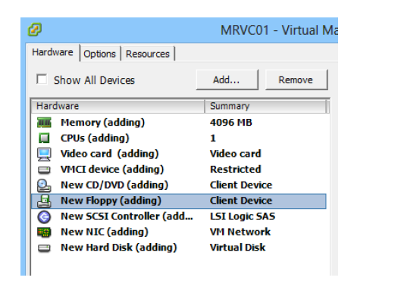

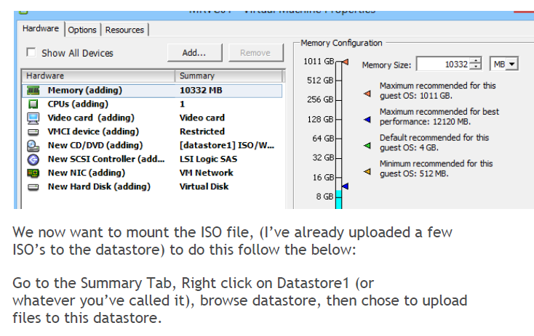

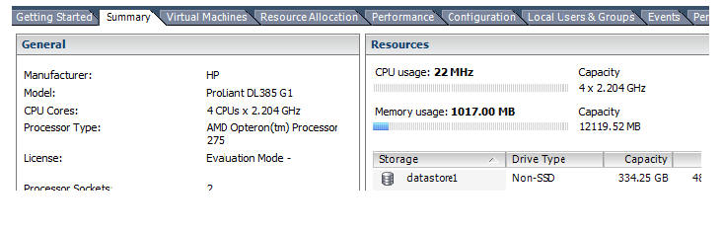

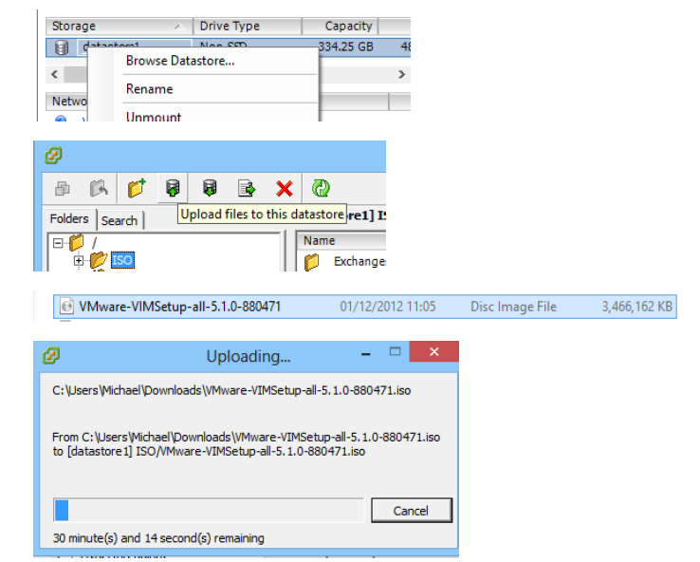

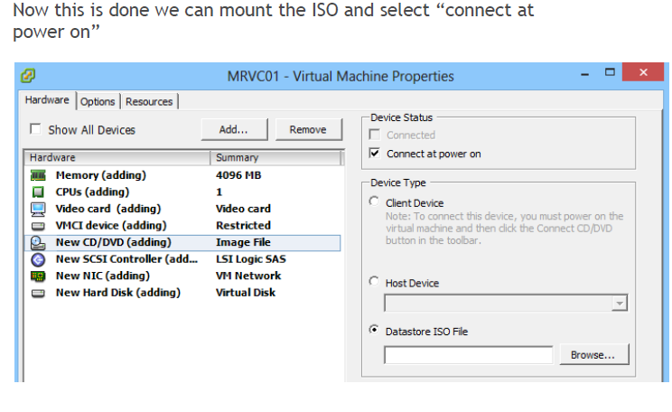

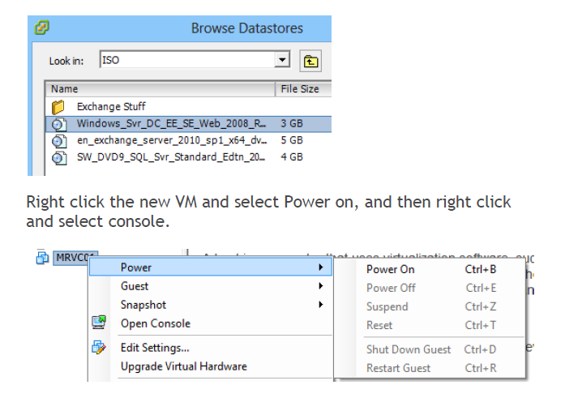

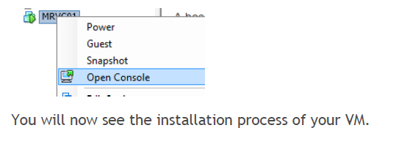

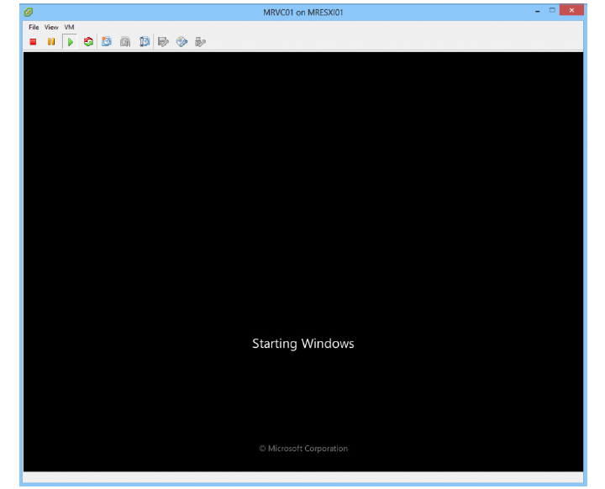

And that’s the basics done.

If all you require is to manage the ESXi Server like this, create/delete Virtual Machines then you are done!

# Practical No 2

**Implementing Xen for server virtualization**

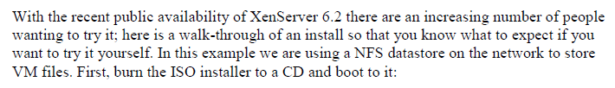

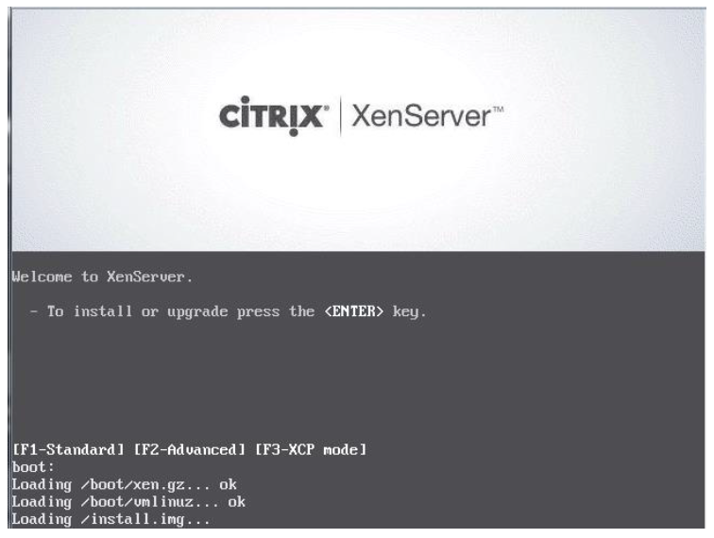



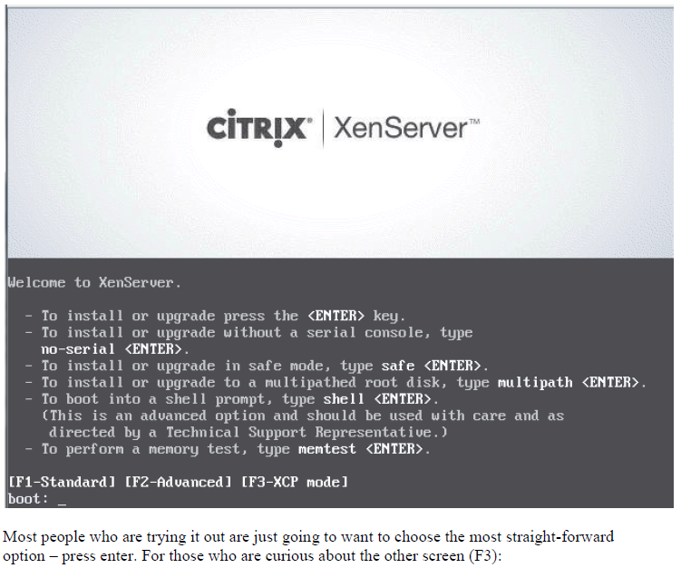

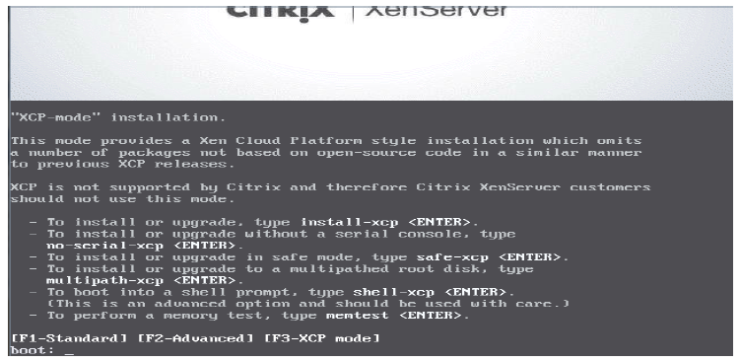



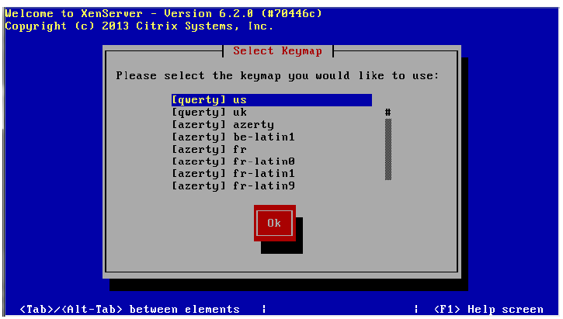

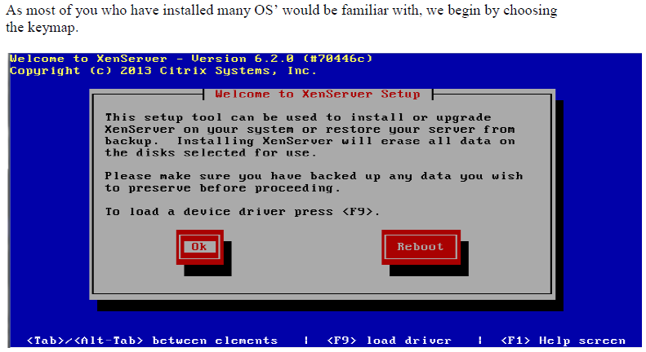



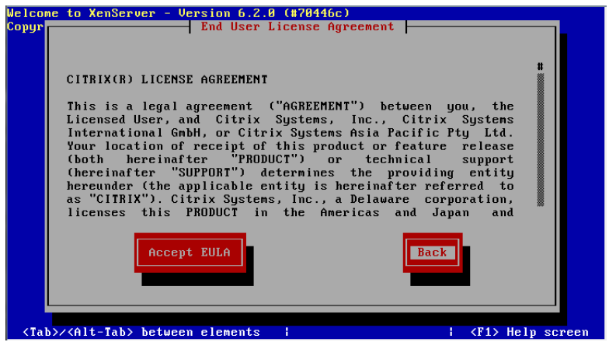



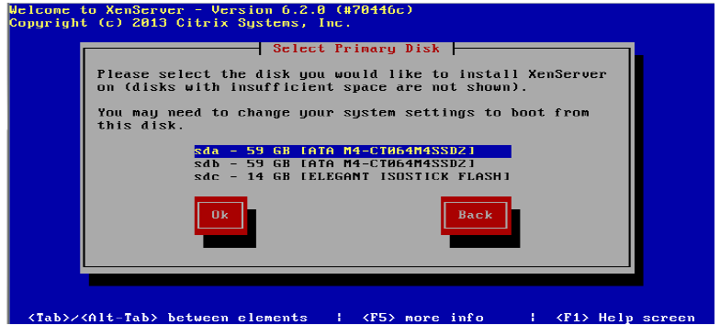

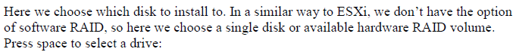

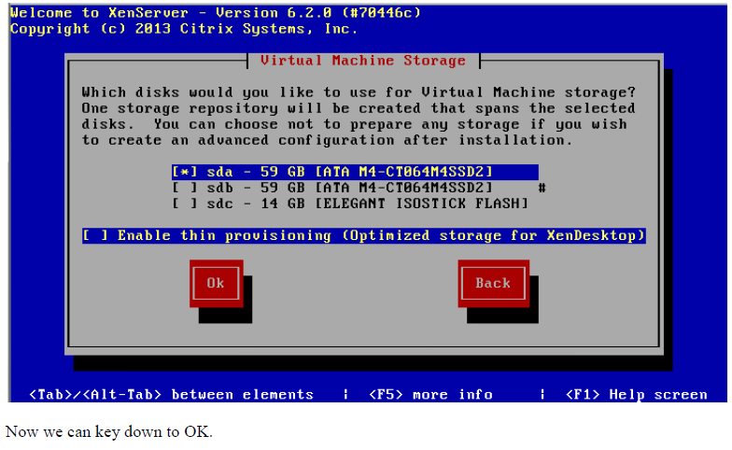

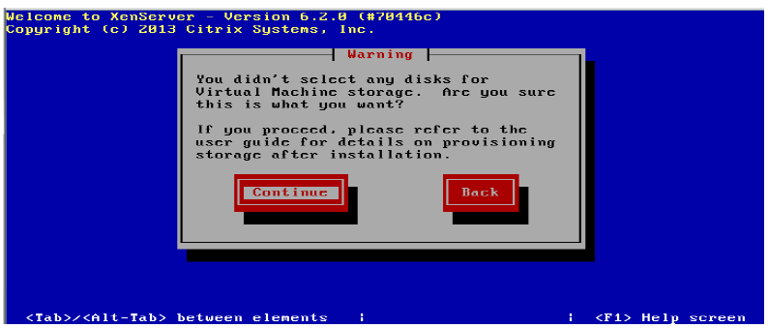



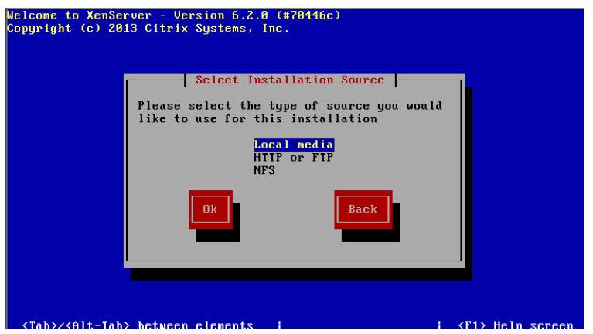



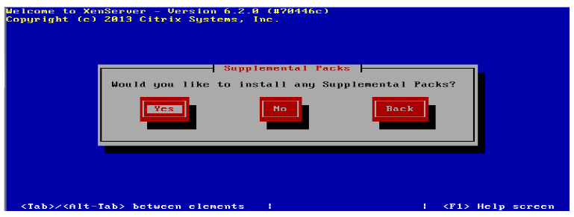



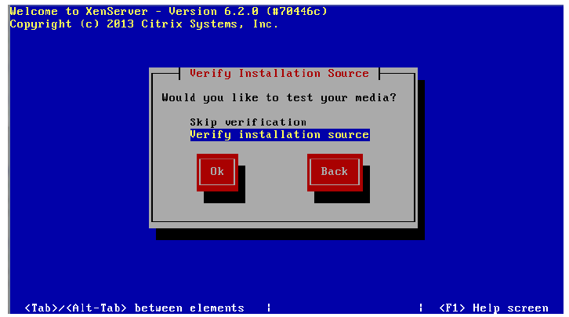



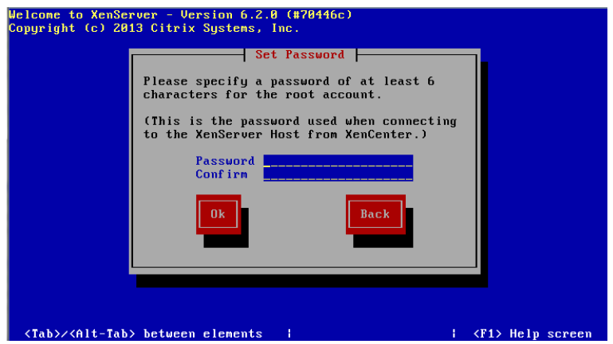





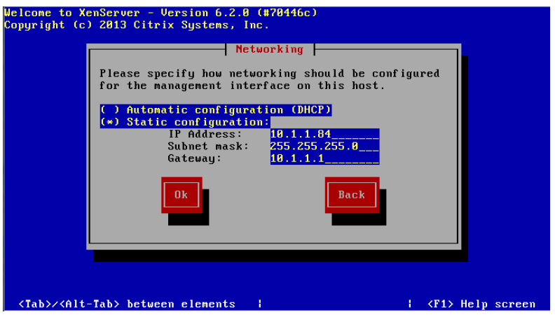

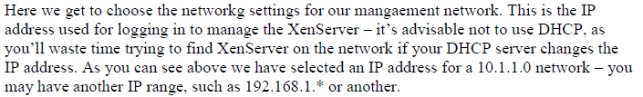

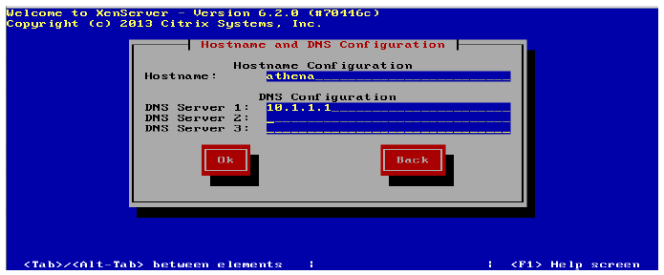



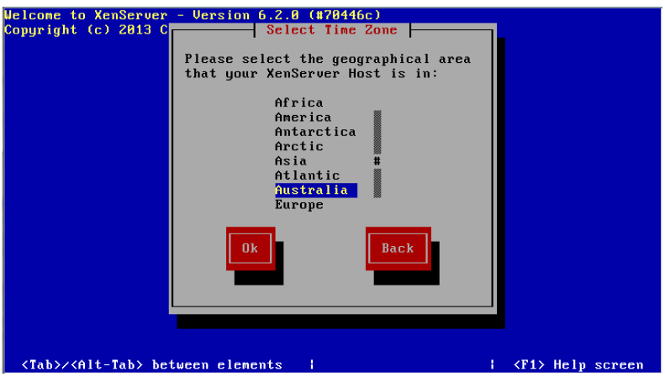



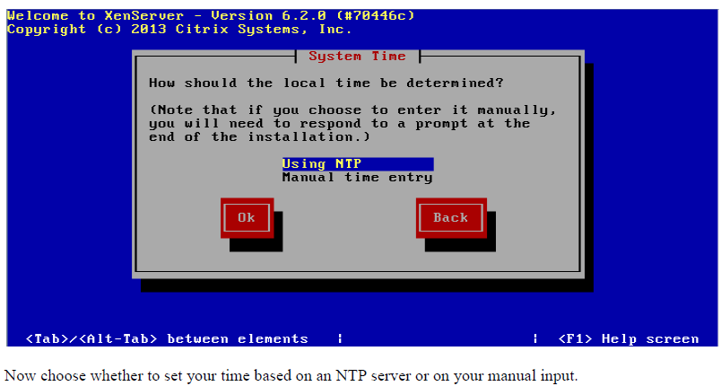

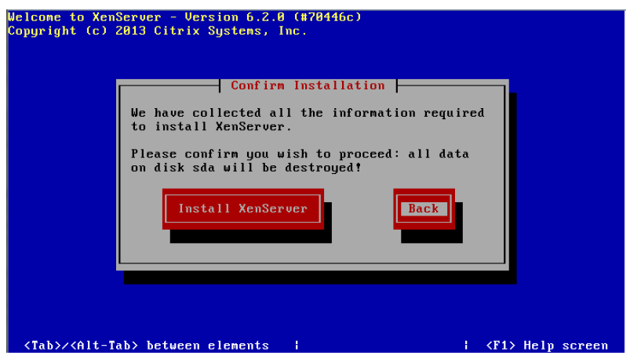



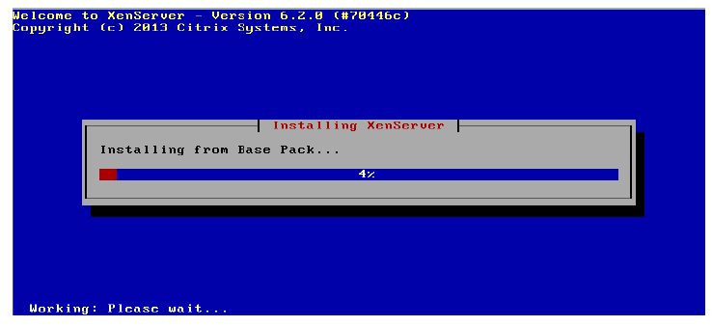



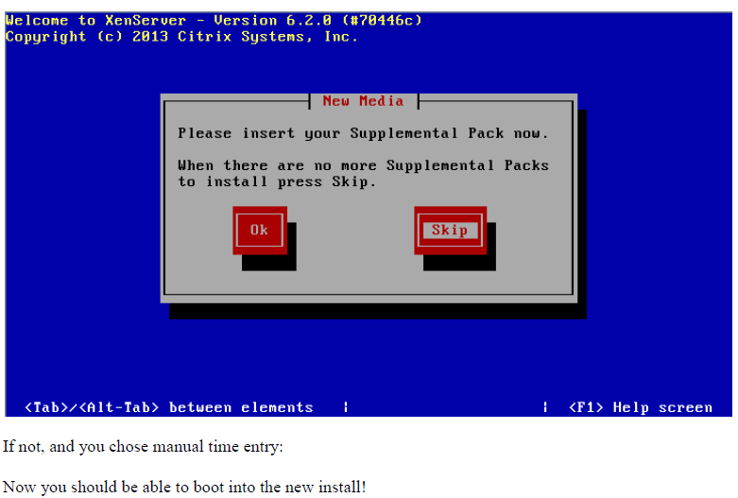





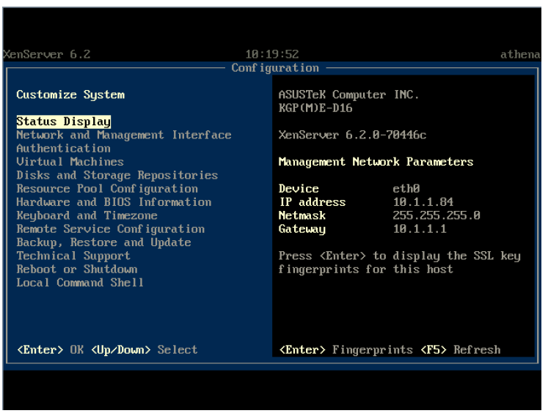

# Practical No 3

**HYPER V SERVER VIRTUALIZATION**

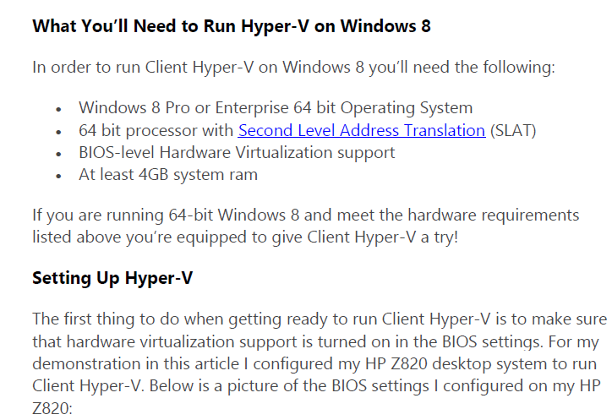

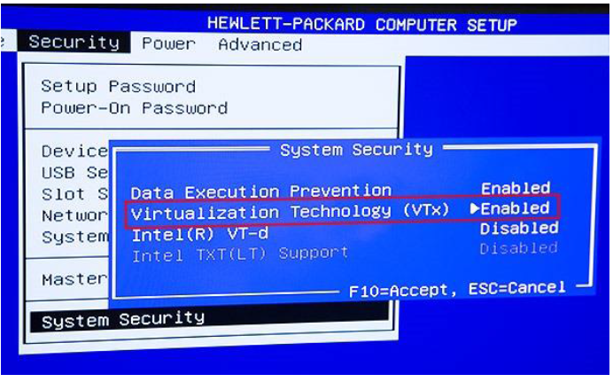

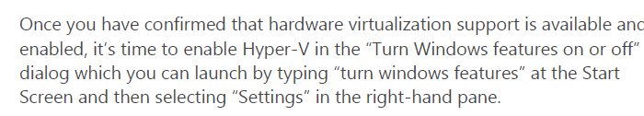

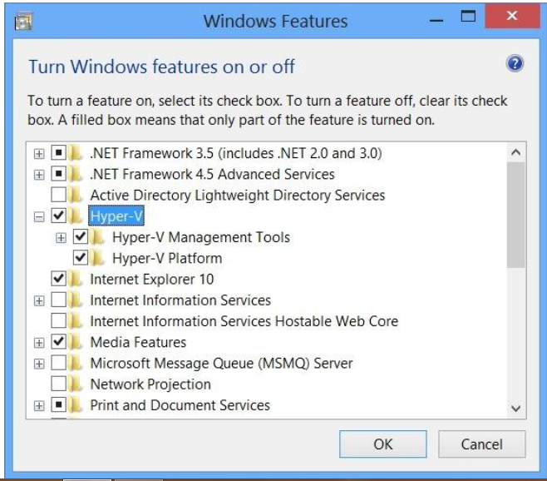

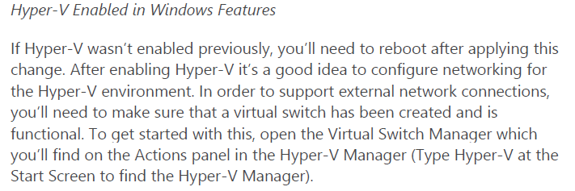

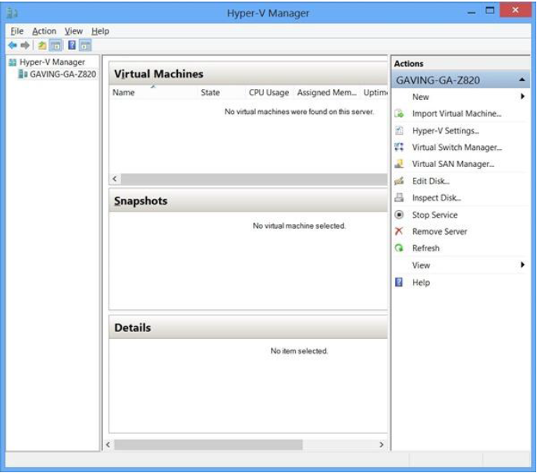

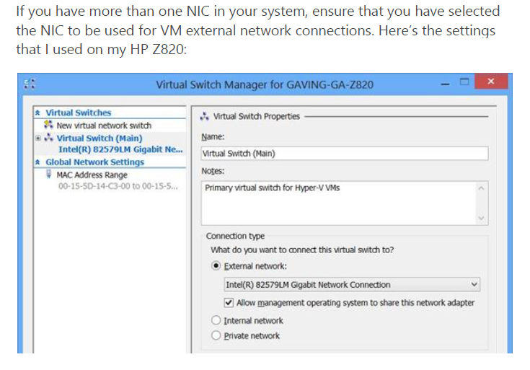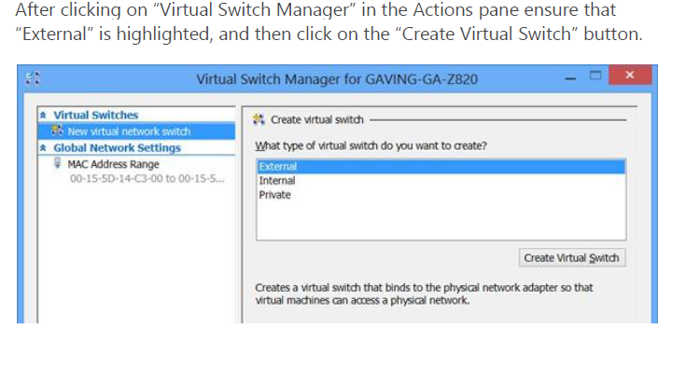

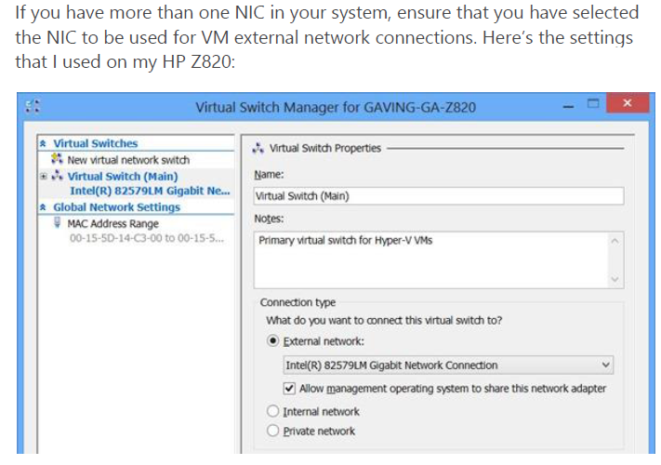

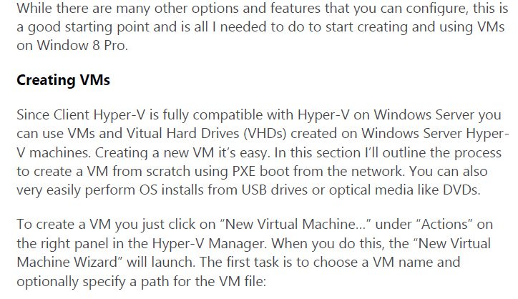

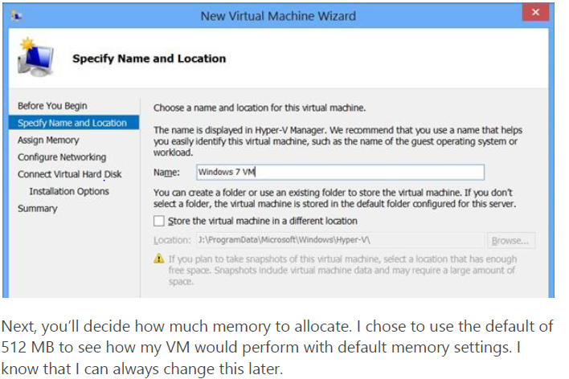

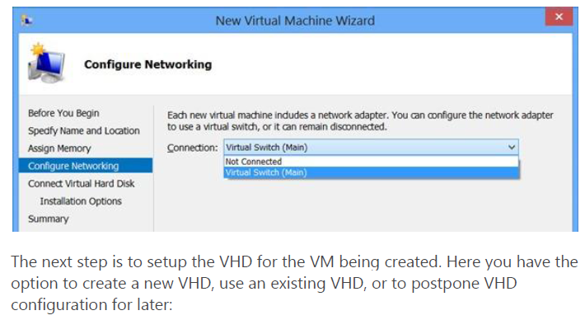

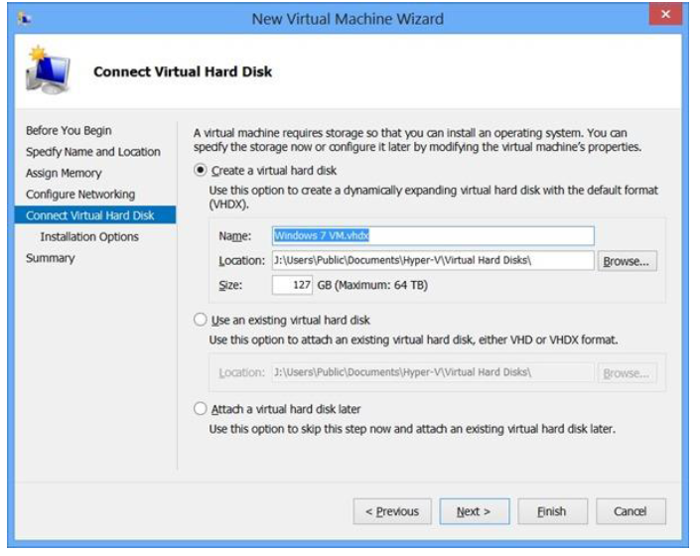

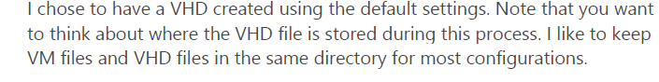

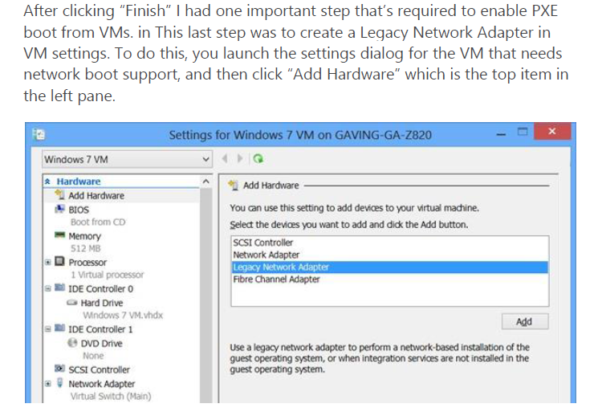

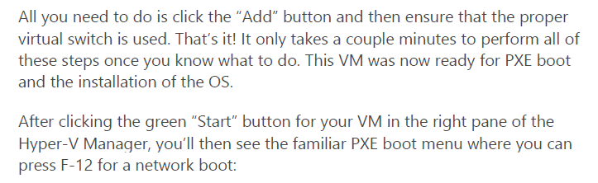

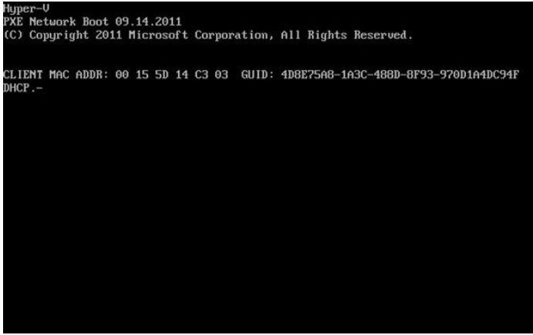



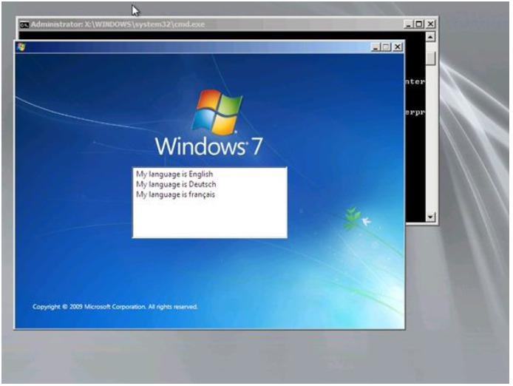

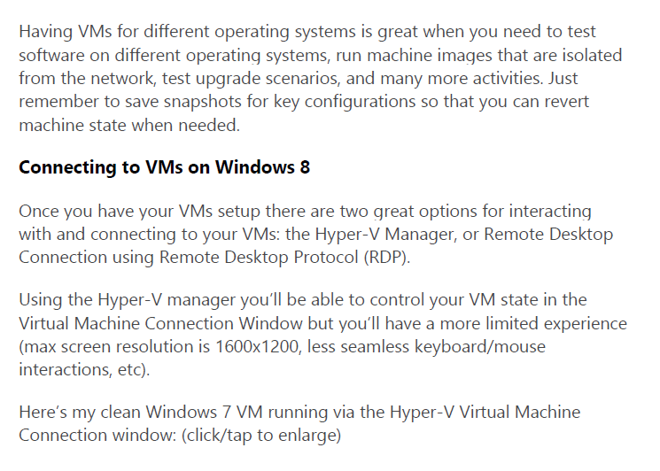

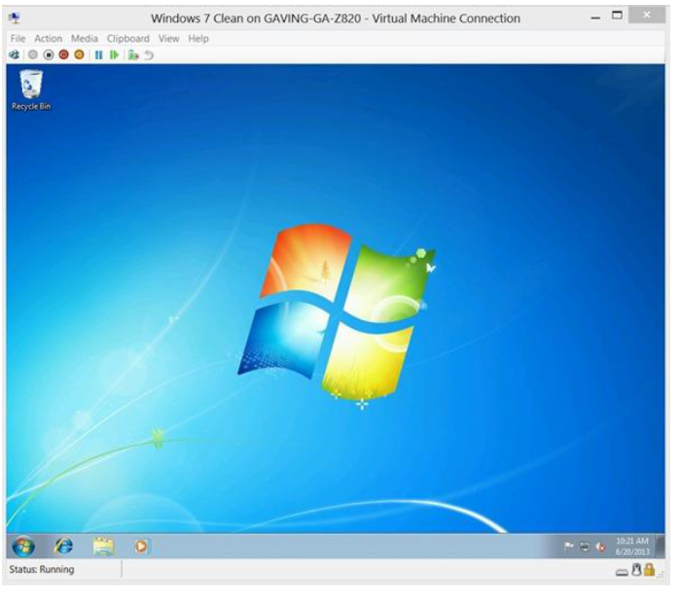

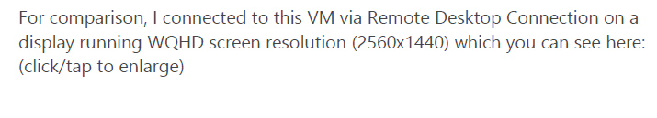

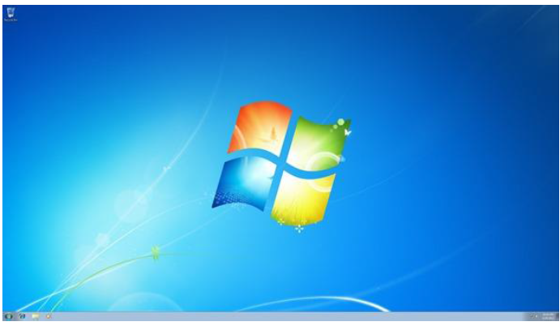

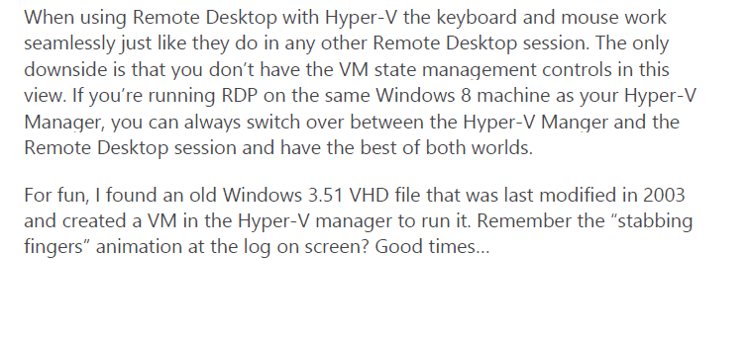

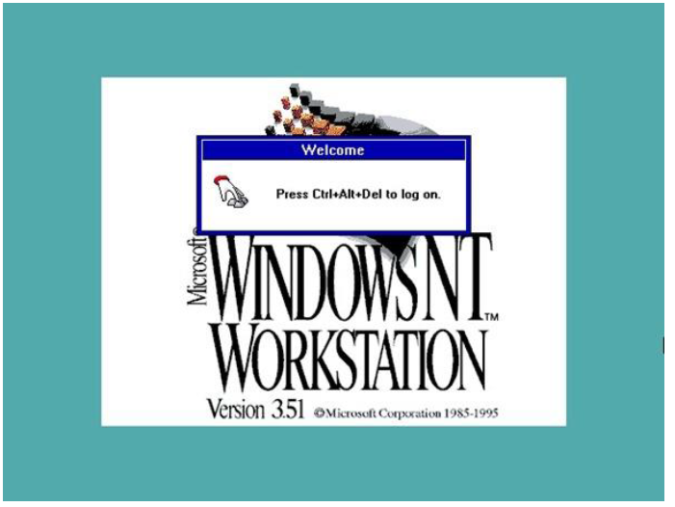

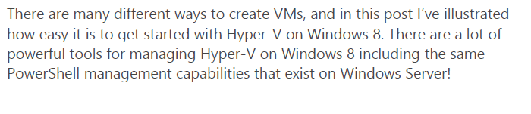

# Practical No 4

**Aim: Manage VMware ESXi with vCentre server**

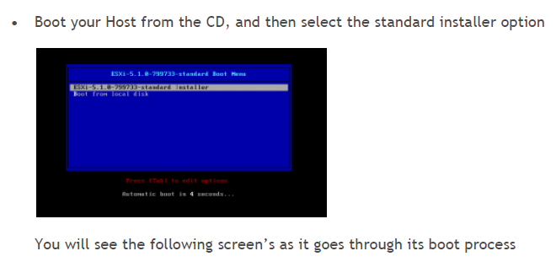

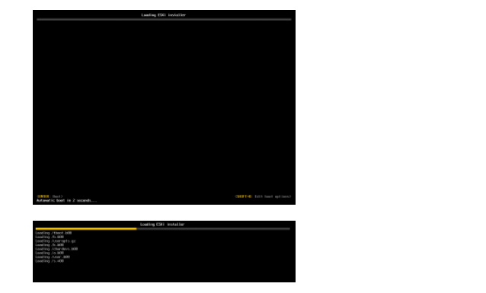

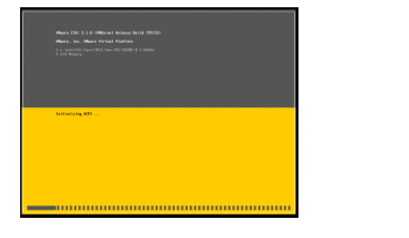

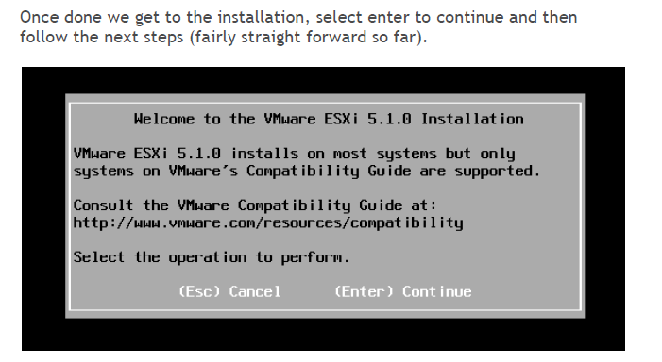

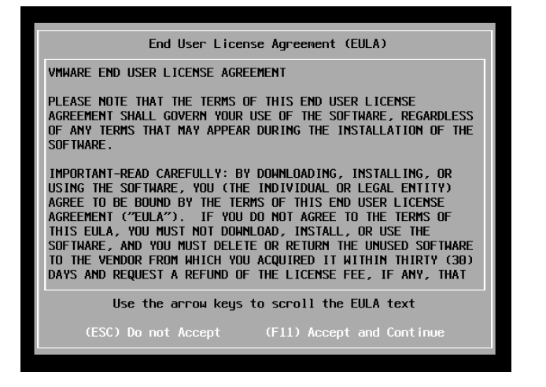

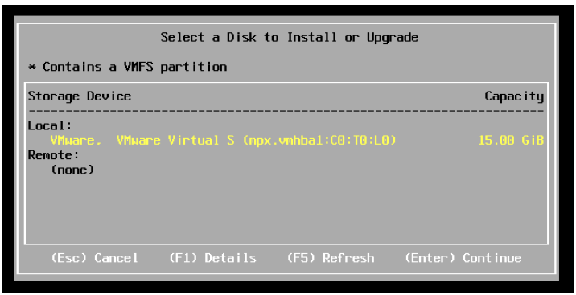

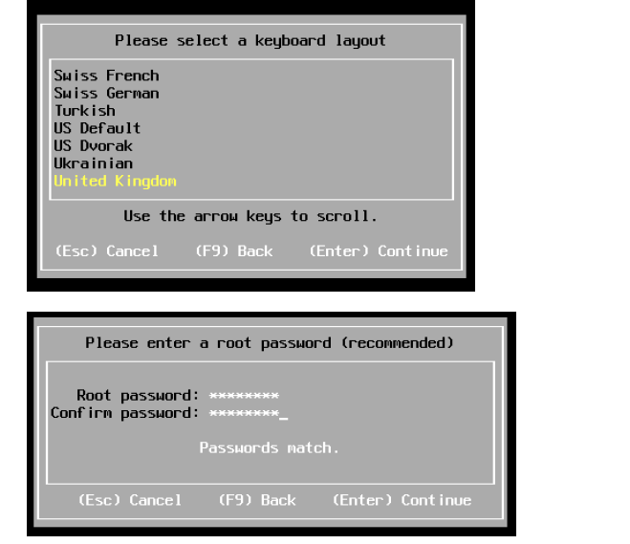

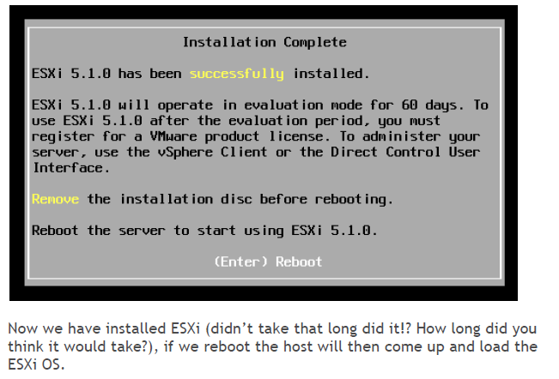

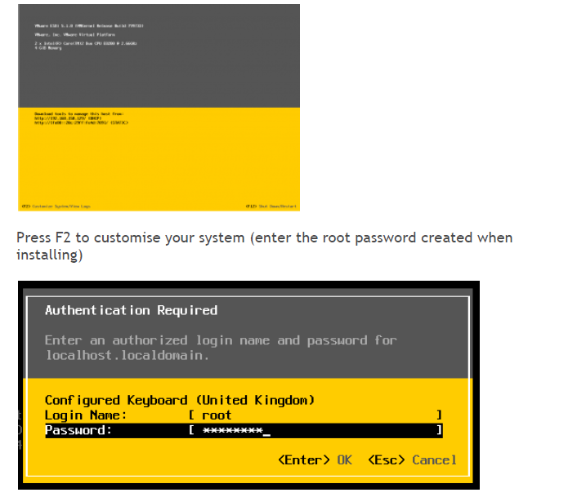

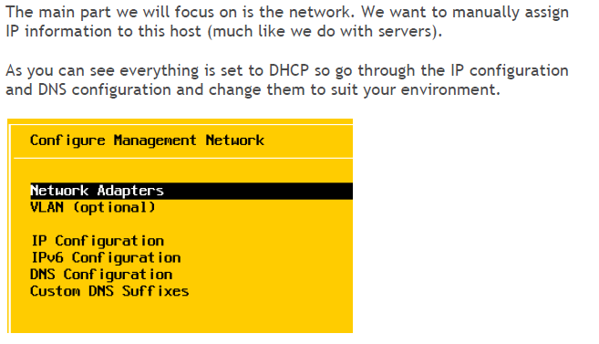

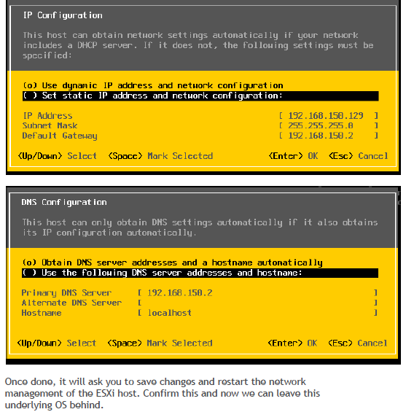

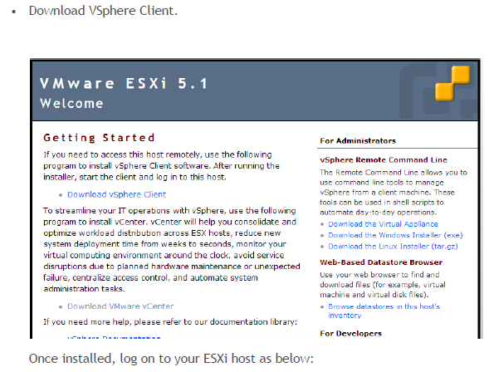

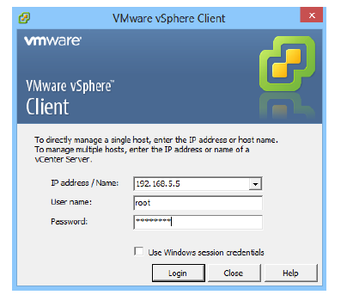

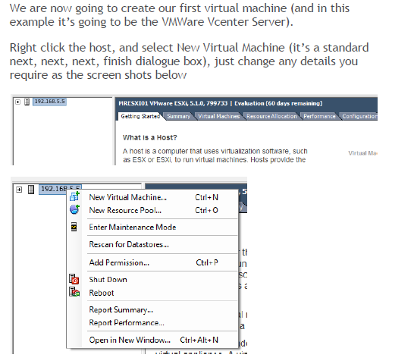

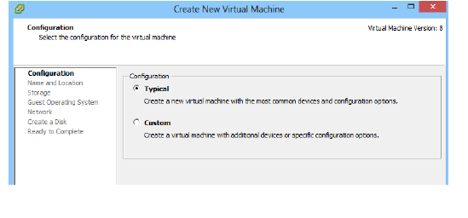

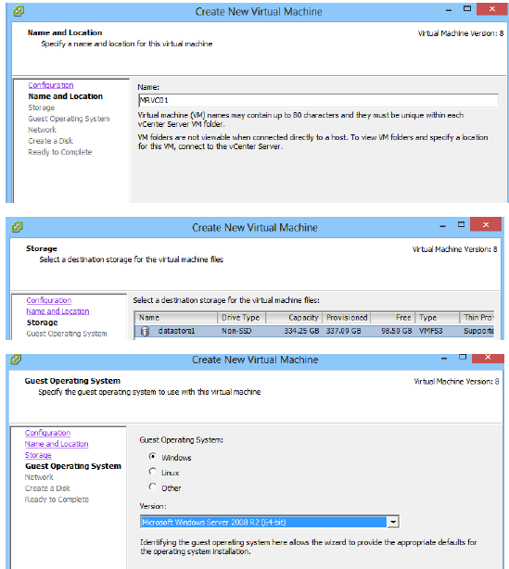

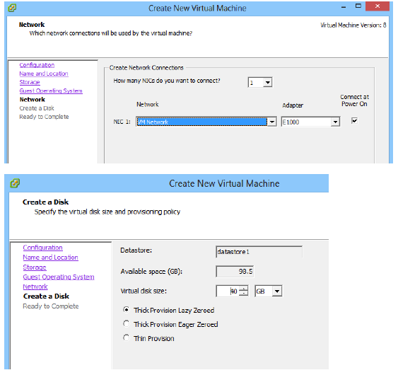

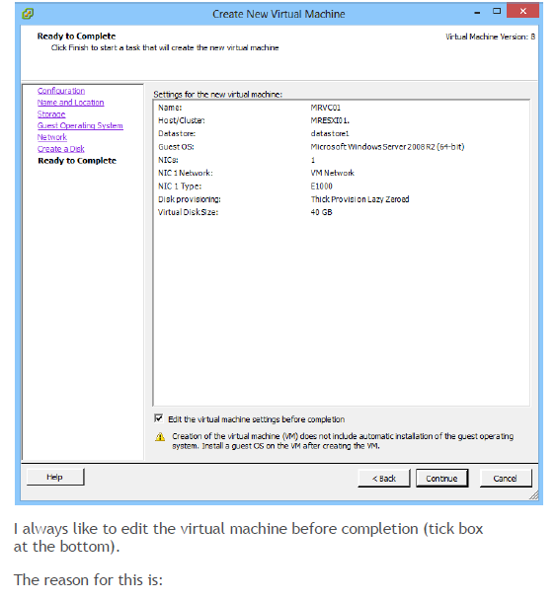

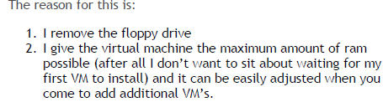

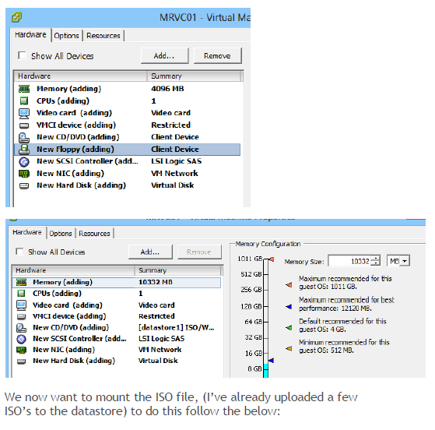

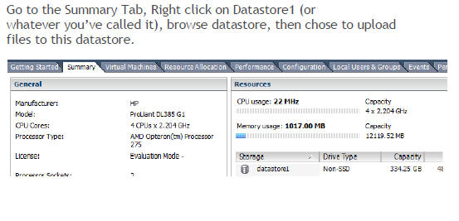

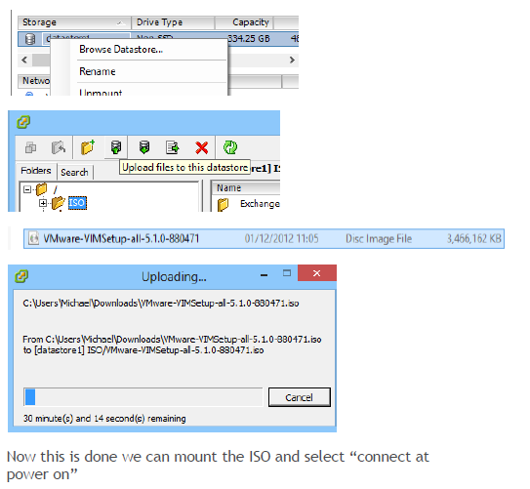

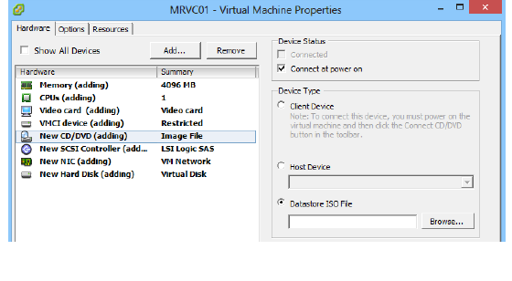

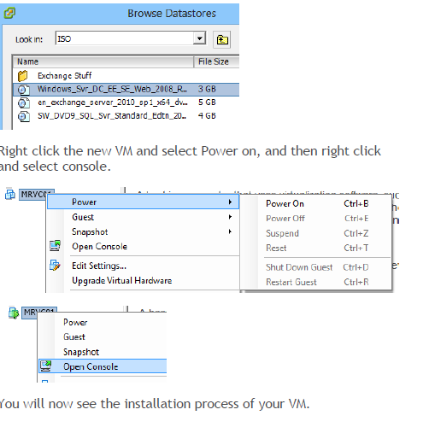

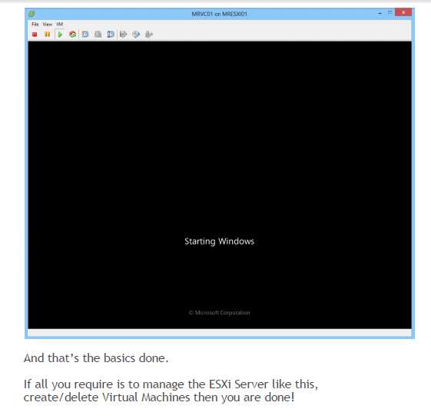

MangingVMcentre

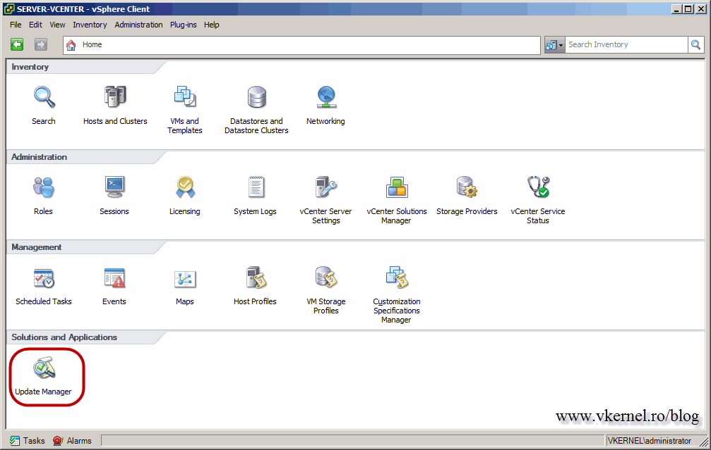

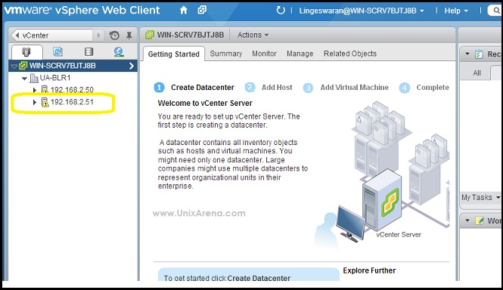

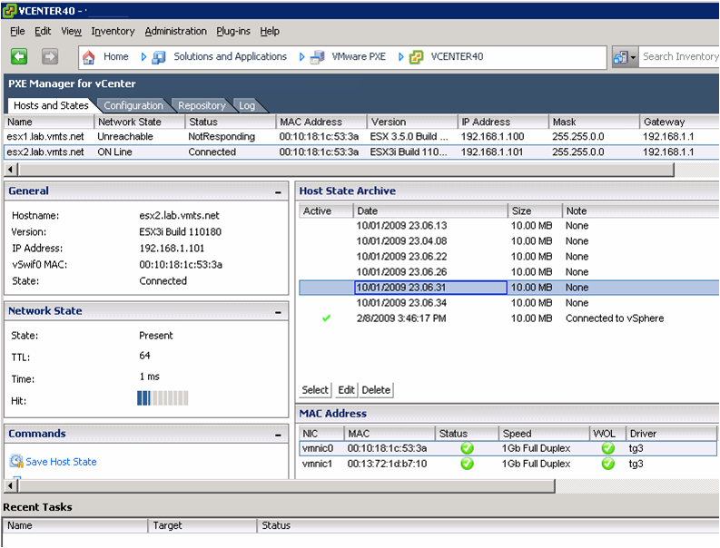

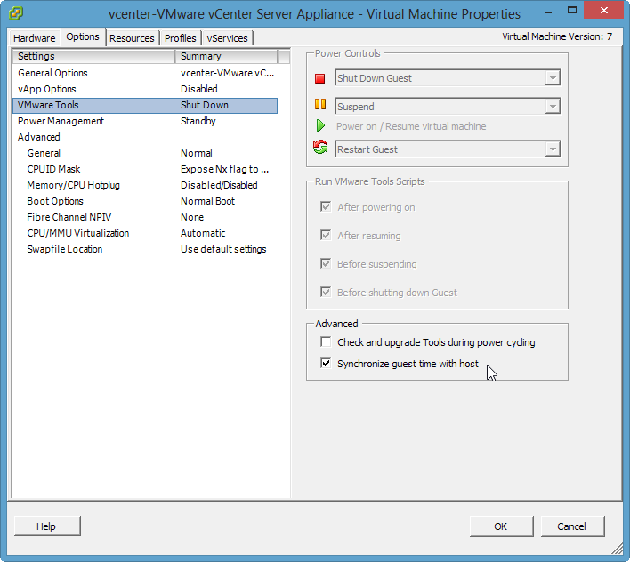

# Practical No 5

Manage xen server Xencentre

**Note: Please refer to the steps of Practical No. 2 before proceeding with the below steps.**

Installing virtual machine using xencenter:

Open Citrix XenCenter

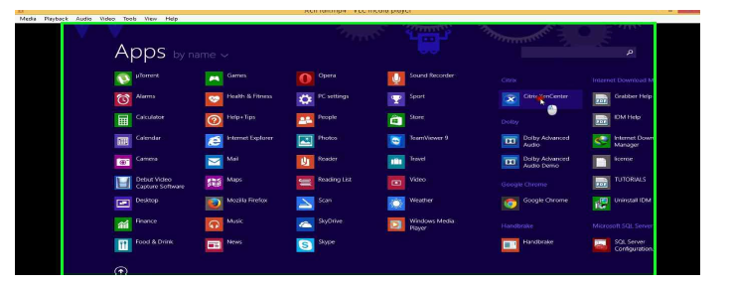

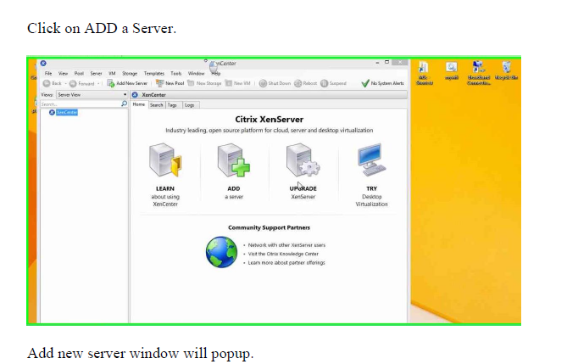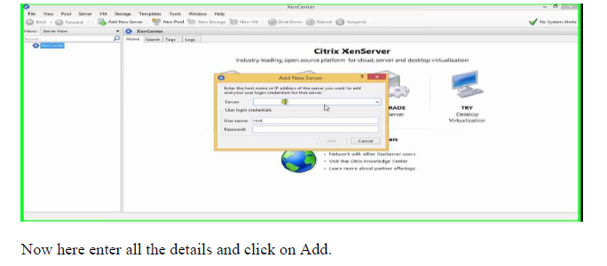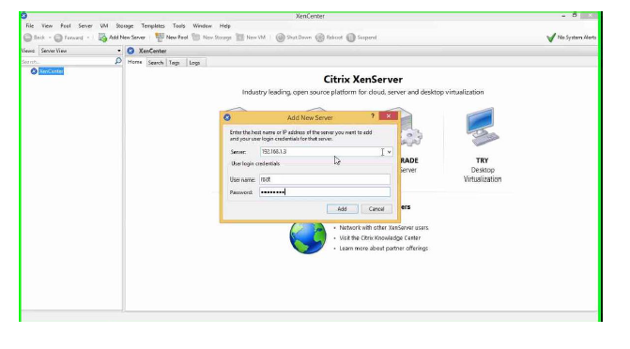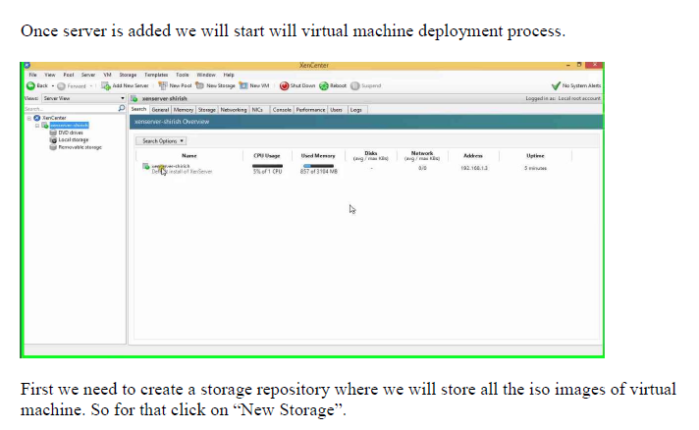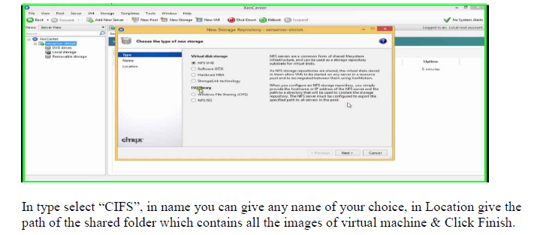

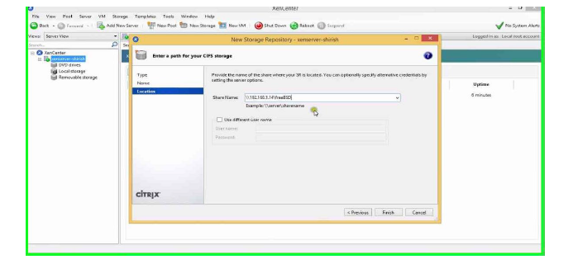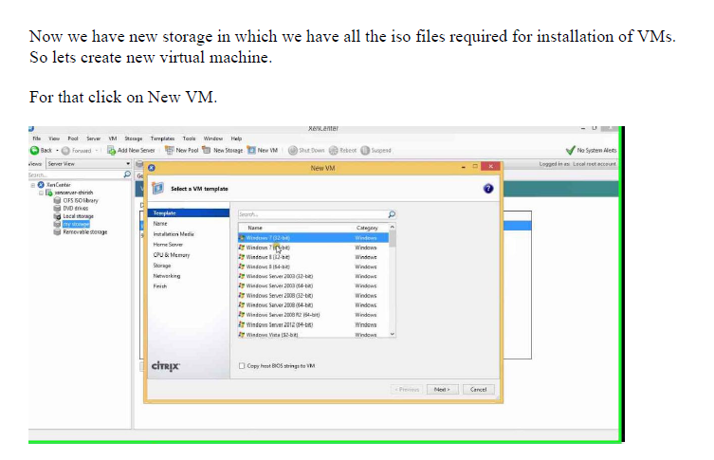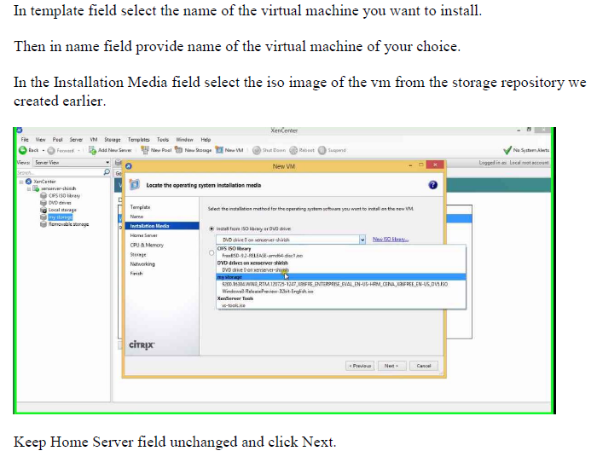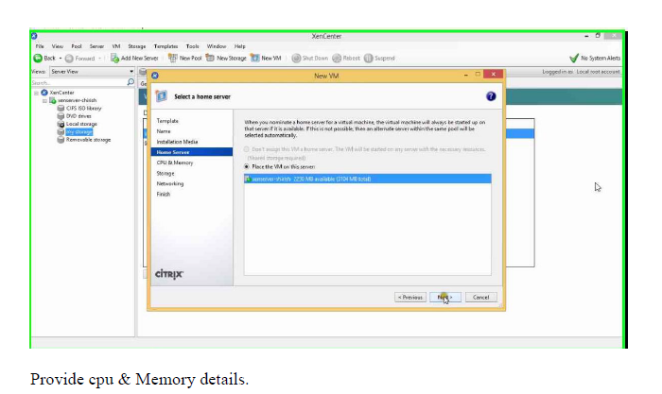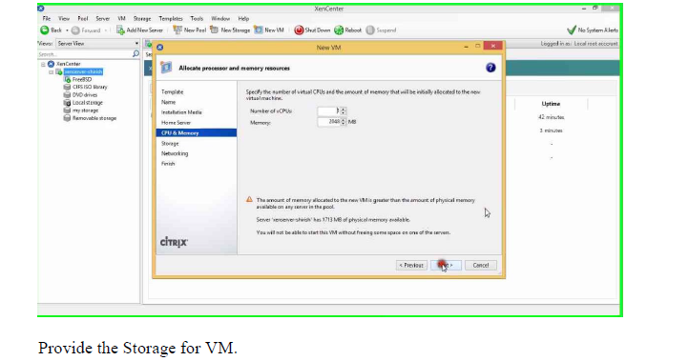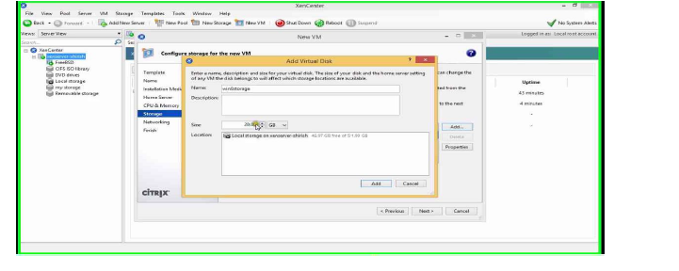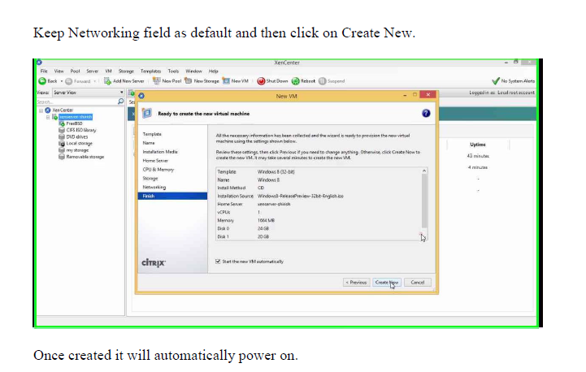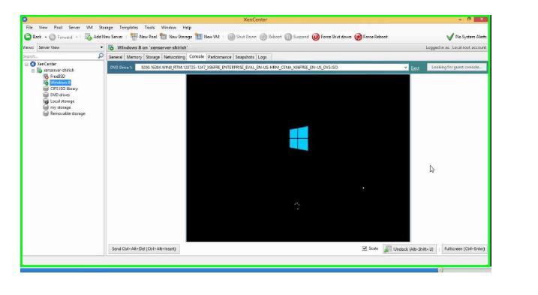

Sign:___________________

# Practical No 6

**Cisco UCS Platform Emulator**

**Hardware Inventory**

The inventory of supported hardware components is stored in the Hardware Catalog.

This catalog is drawn from the Capability Catalog that is included in Cisco UCS Platform Emulator. It contains the inventory of the supported components that you can use to build a chassis in Cisco UCS Platform Emulator, including servers,DIMMs, and adapters. If a component is not included in the Hardware Catalog, it is not supported by Cisco UCS Platform Emulator. The Hardware Catalog does not include fabric interconnects. You need to configure fabric interconnects and the links between the chassis and the fabric interconnect in the emulator settings.

**Startup Hardware Inventory Icons**

The following table contains the icons above the **Stash** and **Chassis** areas on the **Startup Hardware Inventory** 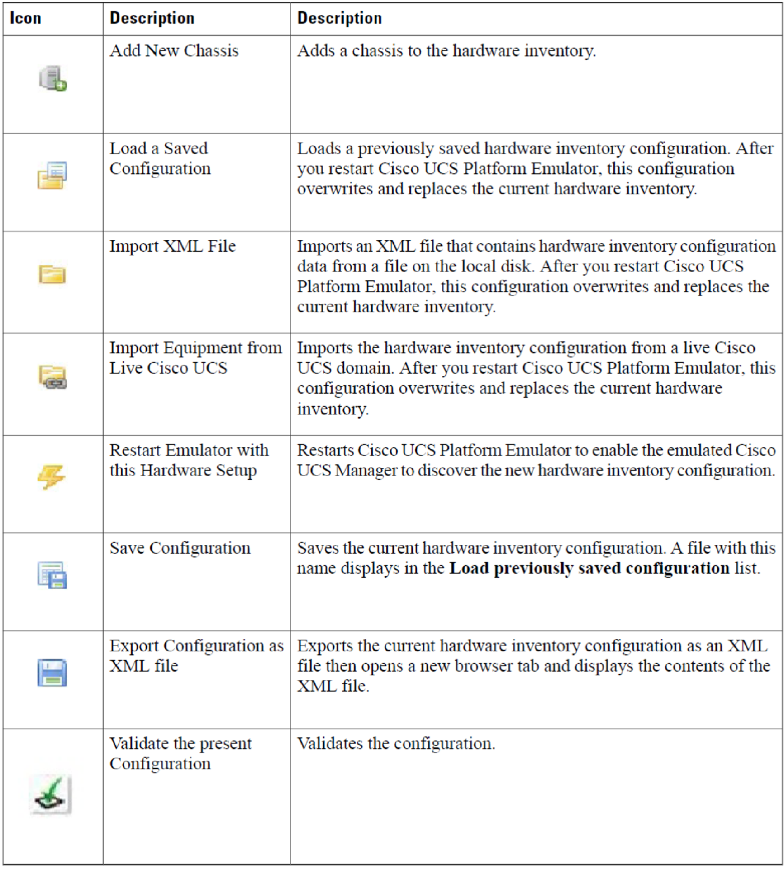

**Inventory Stash Area**

The **Stash** area is a virtual lab desk where you can place a blade server after you remove it from, or before you insert it into a chassis. You can change the components of a server in the **Stash** area, such as the DIMMs or CPU, before you insert the server into a chassis. You can drag and drop servers into the **Stash** area from **26**

**Configuring the Hardware Inventory**

**Inventory Stash Area** the **Chassis** area (after ejection) or from the **Hardware Catalog** table below. If a server in the **Stash** area was removed from a chassis, Cisco UCS Platform Emulator tracks the chassis and slot from which the server was removed and reinserts it back into the same location when you drag and drop the server back into the **Chassis** area. For rack servers, you can place a server in the **Stash** area, change or add components, and then drag and drop the server on the **Rack Servers** area.

You can drag and drop servers into the **Stash** area from the **Chassis** area or from the

Hardware Catalog table below. If a server in the **Stash** area was removed from a chassis, Cisco UCS Platform Emulator tracks the chassis and slot from which the server was removed and reinserts it back into the same location when you drag and drop the server back into the **Chassis** area.

**Stash Area Icons**

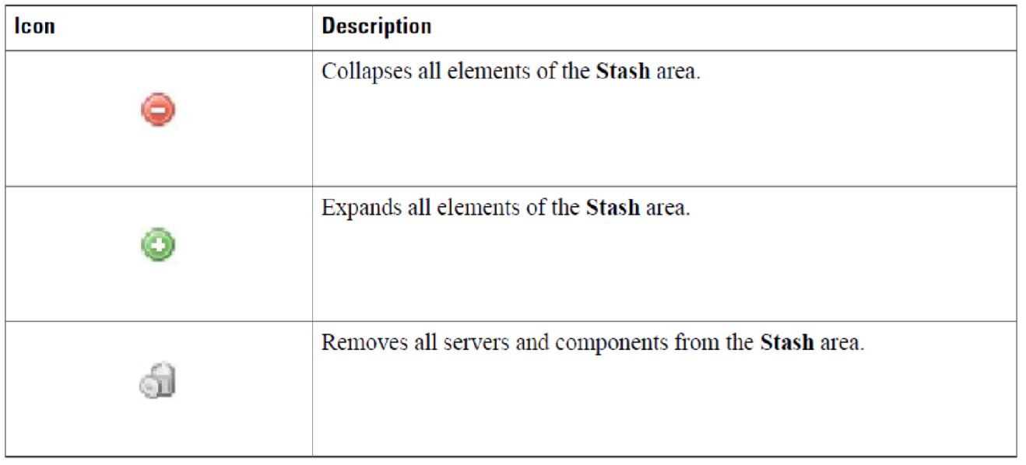

**Chassis Area**

The **Chassis** area holds all of the chassis in Cisco UCS Platform Emulator. By default, the **Chassis** area includes one chassis.

While you can modify servers in the **Chassis** area, we recommend that you drag the server from a chassis and

drop it in the **Stash** area and modify the server components there. When you drag the server back to the

**Chassis** area, Cisco UCS Platform Emulator returns it to the same chassis and slot from which it was removed.

**Viewing the Hardware Catalog**

**Procedure**

**Step 1** In the **Navigation** pane, click the **Emulator Settings** menu tab.

**Step 2** Click **Hardware Catalog**.

**Step 3** In the **Work** pane, click one or more of the following tabs to view the components supported in the current release: • **Blades**

* **CPU**
* **DIMM**
* **HDD**
* **I/O Adapters**
* **Fans**
* **PSU**
* **Rack Servers**
* **Templates**

**28**

**Configuring the Hardware Inventory**

**Viewing the Hardware Catalog**

* **Storage Controller**

**Manually Configuring the Hardware Inventory**

**Adding a New Chassis**

**Procedure**

**Step 1** In the **Navigation** pane, click the **Emulator Settings** menu tab.

**Step 2** Click **Start-up Inventory**.

**Step 3** On the **Startup Hardware Inventory** page, click the **Add New Chassis** icon on the top icon bar.

**Step 4** In the **ID** field, enter an unused number that you want to assign to the chassis. **Step 5** In the **Name** field, enter a name for the chassis.

**Step 6** Click **Add**.

Cisco UCS Platform Emulator adds a **Chassis** area for the new chassis.

Fabric Model UCS-FI-M-6324 is only supported with the chassis UCSB-5108-AC2 and UCSB-5108-DC2. UCS Mini supports only one chassis with a chassis ID value of 1. **Note**

**What to Do Next**

Add servers to the chassis.

**Creating a New Blade Server**

We recommend that you create a new blade server in the **Stash** area. Blade servers that are moved from the startup inventory table to the **Stash** area do not include any components, such as DIMMs, adapters, or fans.

You must add those components and build your blade server before you insert the blade server in a chassis.

After you have added all desired components to the blade server, you can drag it over to and drop it into a

chassis.

**Procedure**

**Step 1** In the **Navigation** pane, click the **Emulator Settings** menu tab.

**Step 2** Click **Start-up Inventory**.

**Step 3** On the **Startup Hardware Inventory** page, click the **Blades** tab.

**Step 4** Click in the row for the desired blade server and, holding the mouse button down, drag the blade server to the

**Stash** area and drop it into that area.

**Step 5** Add the components that you want to include in the blade server, as follows: **Cisco UCS Platform Emulator User Guide, Release 3.0(1cPE1)**

**29**

**Configuring the Hardware Inventory Manually Configuring the Hardware Inventory**

1. Click on the tab for the component you want to add to the blade server.
2. Click in the row for the desired configuration for the component and, holding the mouse button down, drag the component to the **Stash** area and drop it on top of the blade server.
3. If prompted, enter the desired slot number for the component and press Enter.
4. Repeat Steps a through c until you have added all desired components to the blade server.

**Step 6** Add the blade server to a chassis:

1. Click on the blade server in the **Stash** area and, holding the mouse button down, drag the component to the appropriate **Chassis** area and drop it into that area.
2. In the **Enter Server Slot** field, enter the number of the empty slot where you want to insert the blade server and press Enter.
3. In the **Enter Server Slot** field, enter the number of the empty slot where you want to insert the blade server and press Enter

Power On the virtual machine and press any key to start the installation process. Note that the vm performs a one-time installation process the first time it starts up. Allow the installation to complete before you reboot the VM. By the way, do something else because it will take some time at least on my old Core-i5 760 :P

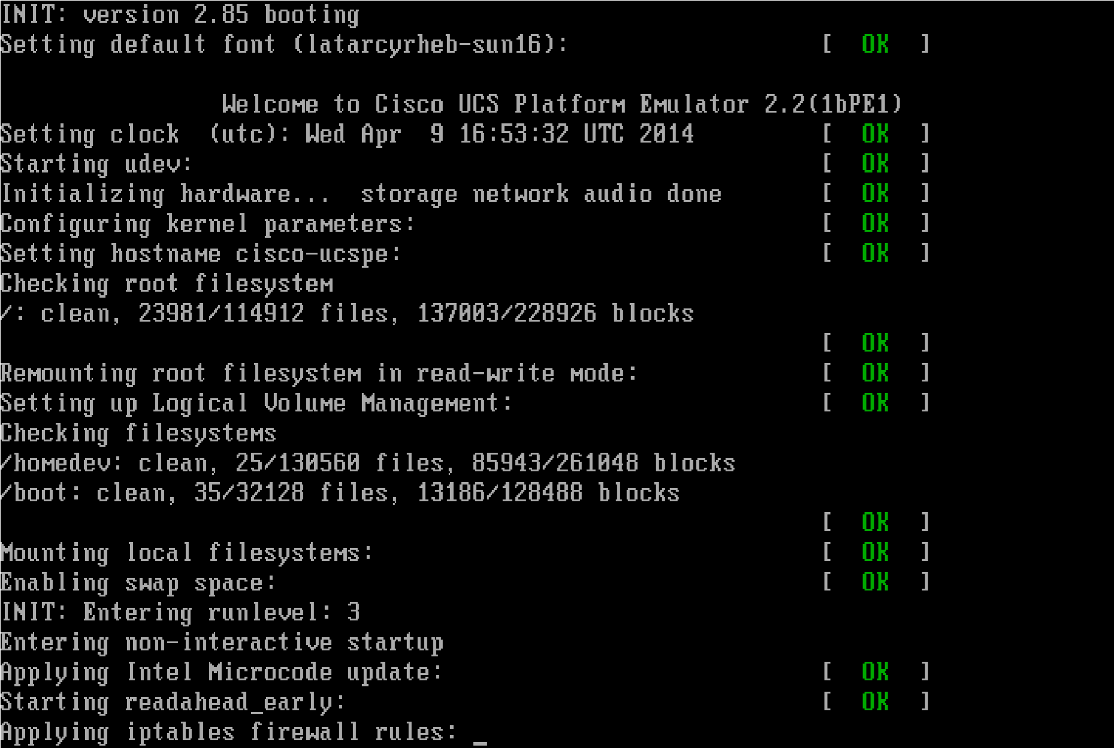

**Here is the first login screen:**

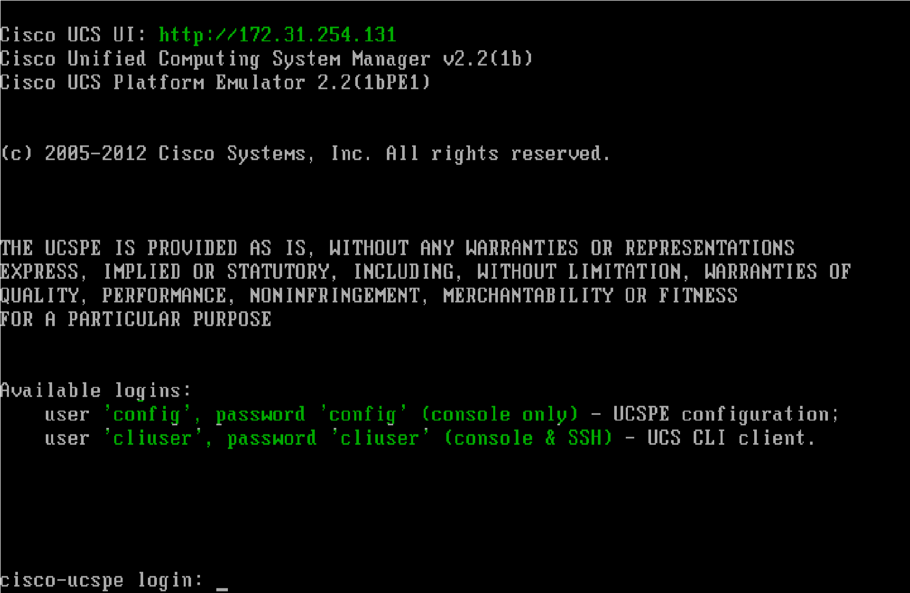

If you login via vmware console, you are presented with a menu for basic configurations, system reboots and shutdowns. Username: config / Password: “config”.

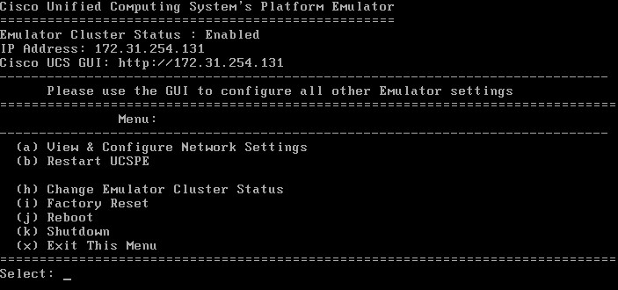

From my management station which is a Windows Server 2012 R2, we can now fire up the browser pointing it to 172.31.254.131 but first lets SSH into it to check it out. Accept the certificate and login with Username / Pasword “**cliuser**“

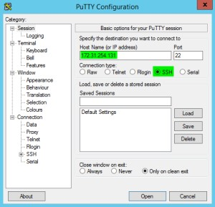

**Andhere is the welcome from Cisco:**

login as: **cliuser**cliuser@172.31.254.131's password:

Last login: Wed Apr 9 22:30:31 2014 from 192.168.1.88

EMULATOR NOTE: connect nxos AND connect local-mgmt COMMANDS ARE NOT

SUPPORTED

Cisco Nexus Operating System (NX-OS) Software TAC support:

http://www.cisco.com/tac

Copyright (c) 2009, Cisco Systems, Inc. All rights reserved. The copyrights to certain works contained in this software are owned by other third parties and used and distributed under license. Certain components of this software are licensed under the GNU General Public License (GPL) version 2.0 or the GNU

Lesser General Public License (LGPL) Version 2.1. A copy of each such license is available at

http://www.opensource.org/licenses/gpl-2.0.php and

http://www.opensource.org/licenses/lgpl-2.1.php

cisco-ucspe#

This is a nice look and feel for an emulator and to be honest I‘m not familiar with UCS that much. The only contact I had with it was in my last job working on a NOC. I had to troubleshoot a lot of systems and networking equipment including UCS, mainly faults and chassis temperature but it doesn’t feel that hard but of course you need to know your stuff. Something that now I can spend some time on. Just need the materials for studying.

cisco-ucspe# **show version**System version: 2.2(1b) cisco-ucspe# **show chassis environment detail** Chassis 1:

Overall Status: Accessibility Problem

Operability: Operable

Power State: Ok Thermal Status: N/A cisco-ucspe#

Exploring the cli a bit further this is what is at our disposal:

cisco-ucspe# **?**acknowledgeAcknowledge backup Backup clear Clear managed objects commit-buffer Commit transaction buffer connect Connect to Another CLI decommission Decommission managed objects

deleteDelete managed objects discard-buffer Discard transaction buffer end Go to exec mode exit Exit from command interpreter recommissionRecommission Server Resources

remove Remove restore-check Check if in restore mode scope Changes the current mode set Set property values show Show system information terminal Terminal top Go to the top mode ucspe-copy Copy a file in UCSPE up Go up one mode

where Show information about the current mode cisco-ucspe#

You UCS geeks may take my doubts away but this looks just like the real thing!

cisco-ucspe# **show server inventory bios detail**Server 1/1:

Equipped Product Name: Cisco UCS B200 M1

Equipped PID: N20-B6620-1

Equipped VID: V01

Equipped Vendor: Cisco Systems Inc

Equipped Serial (SN): 3324

Equipped Revision: 0

Slot Status: Equipped

Acknowledged Product Name: Cisco UCS B200 M1

Acknowledged PID: N20-B6620-1

Acknowledged VID: V01

Acknowledged Vendor: Cisco Systems Inc

Acknowledged Serial (SN): 3324

Acknowledged Revision: 0

Acknowledged Memory (MB): 8192

Acknowledged Effective Memory (MB): 8192

Acknowledged Cores: 6

Acknowledged Adapters: 1

Acknowledged Burned-In UUID: 1b4e28ba-2fa1-11d2-0101-b9a761bde3fb

Acknowledged Dynamic UUID: 1b4e28ba-2fa1-11d2-0101-b9a761bde3fb

Bios:

Model: N20-B6620-1 Revision: 0 Serial:

Vendor: Intel Corp.

Server 1/2:

Equipped Product Name: Cisco UCS B200 M1

Equipped PID: N20-B6620-1

Equipped VID: V01

Equipped Vendor: Cisco Systems Inc

Equipped Serial (SN): 3325

Equipped Revision: 0

Slot Status: Equipped

Acknowledged Product Name: Cisco UCS B200 M1

Acknowledged PID: N20-B6620-1

Acknowledged VID: V01

Acknowledged Vendor: Cisco Systems Inc

Acknowledged Serial (SN): 3325

Acknowledged Revision: 0

--More--

Let’s head on to the management web page. Point your browser to **172.31.254.131** :

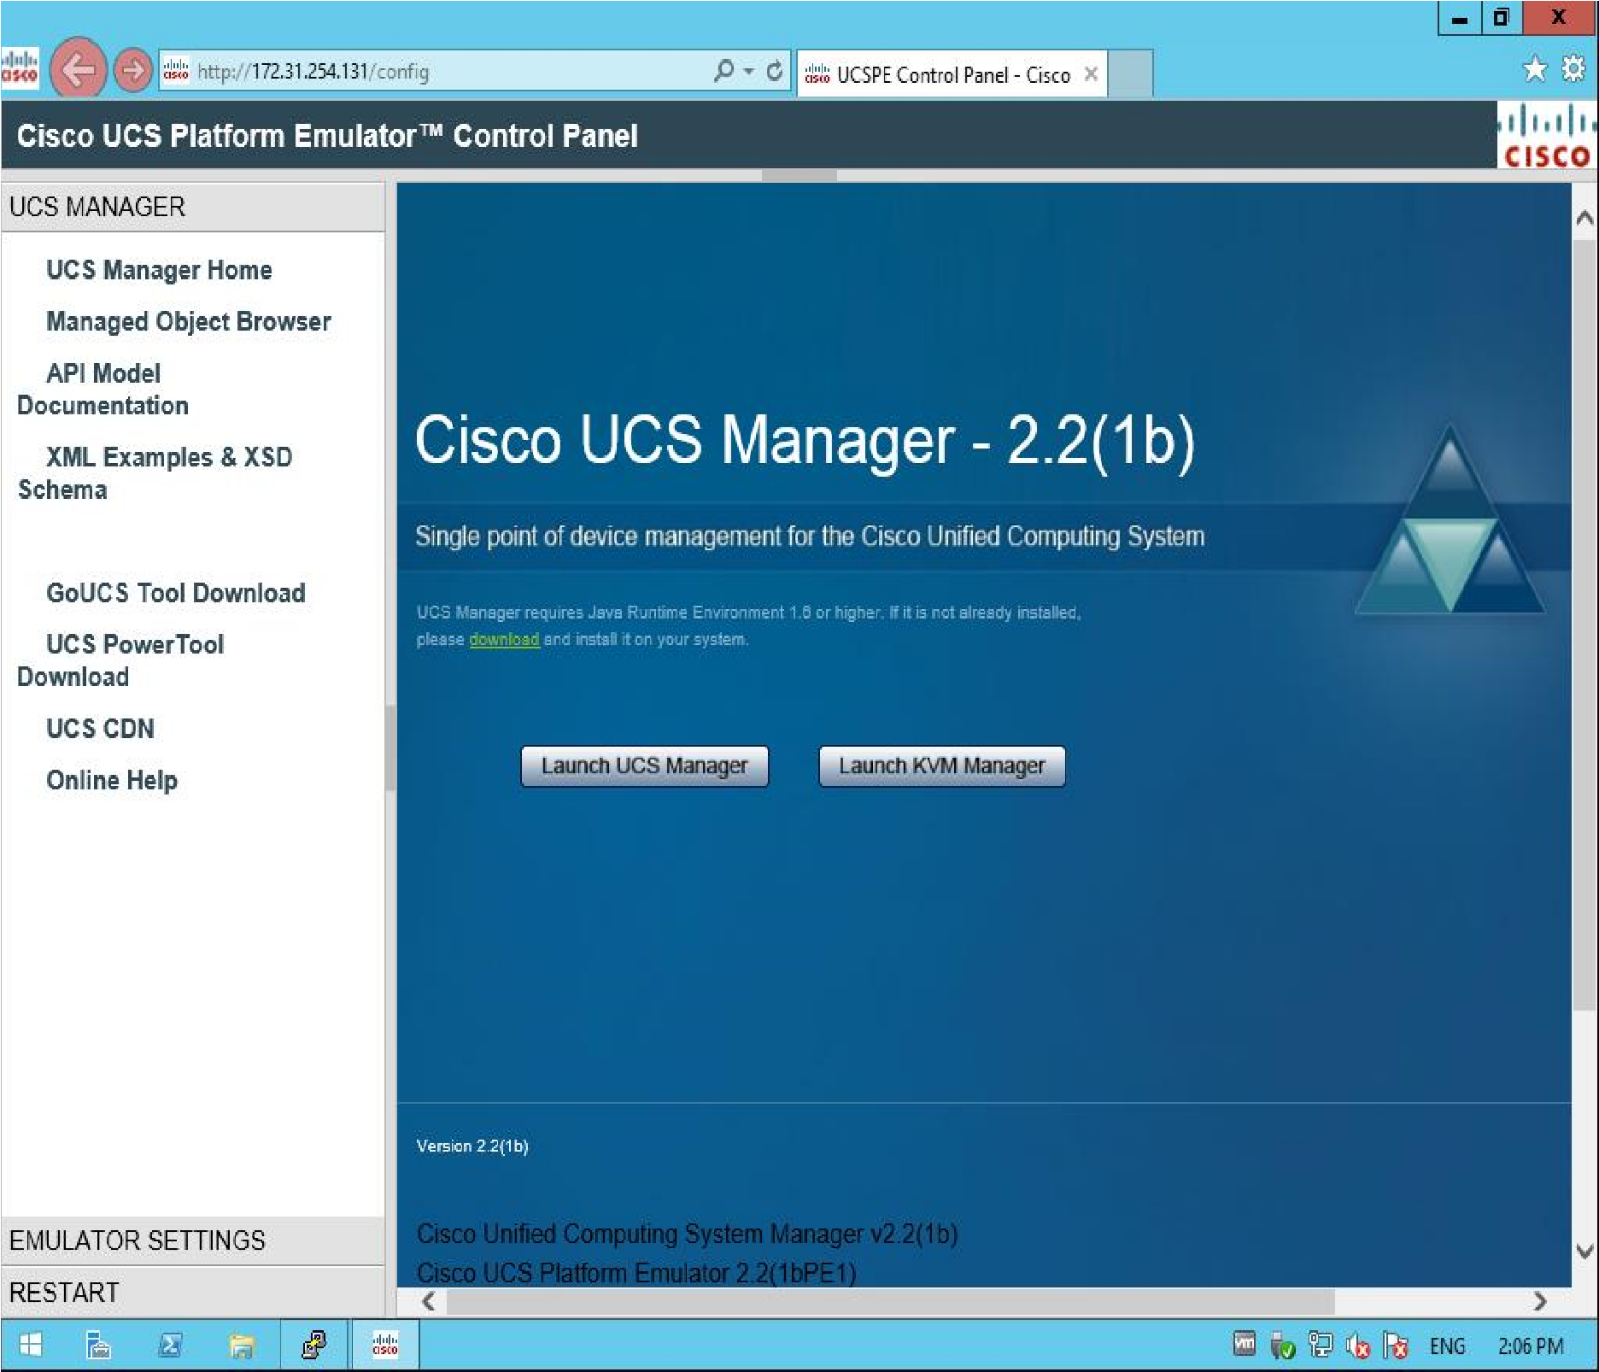

You can see the menu on your left side pane which has UCS Manager, and a lot more tools. Let’s explore it. In “**Emulator settings**”, if you choose “**Startup Hardware Inventory**” you can add blades to the stash by dragging and dropping from the “**Blades**” items. I’ll just drag the first blade “**Cisco UCS B200 M3 2 Socket Blade Server**”

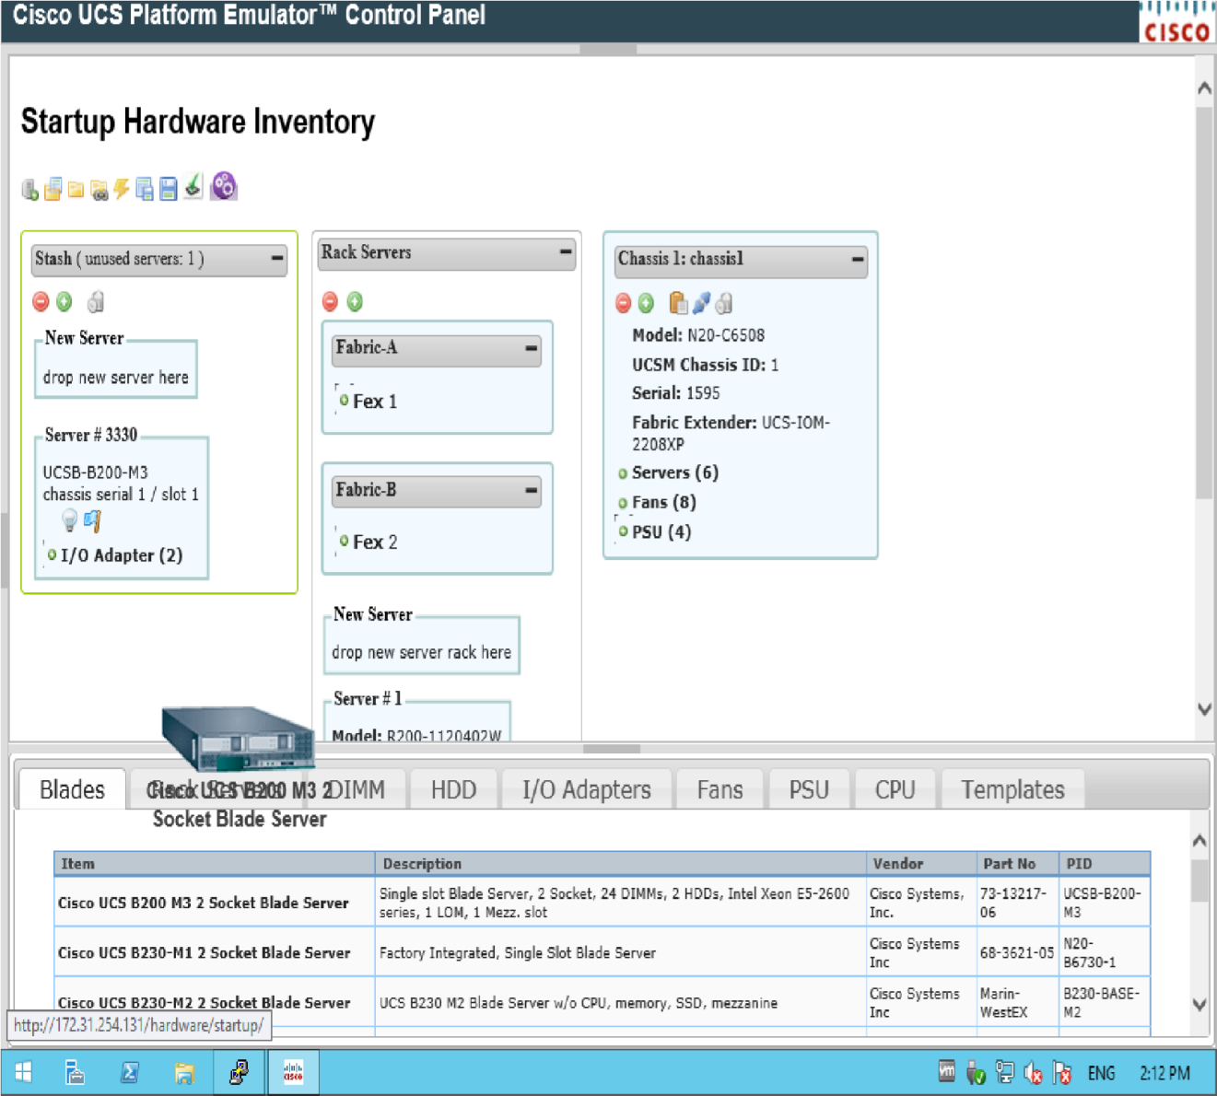

As you can see you can just drag and drop the blades into the stash. Fabric A and Fabric B are already in place. Let’s open UCS manager and see how this emulator looks like. I have a feeling it’s just the same as the real thing but before we do it, let’s configure the rest of the properties.

**Status Summary**

You can check the runtime status, management IP address, emulator options.

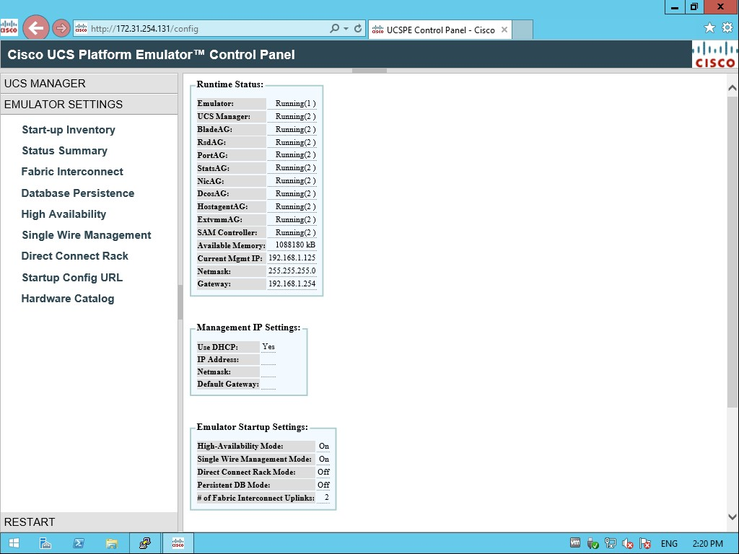

**Fabric Interconnect**

Choose the model you wish, I’ll just use UCS 6296UP 2RU Fabric, you can choose what you like. Don’t be afraid, you can always reset it to factory default. Select and hit submit.

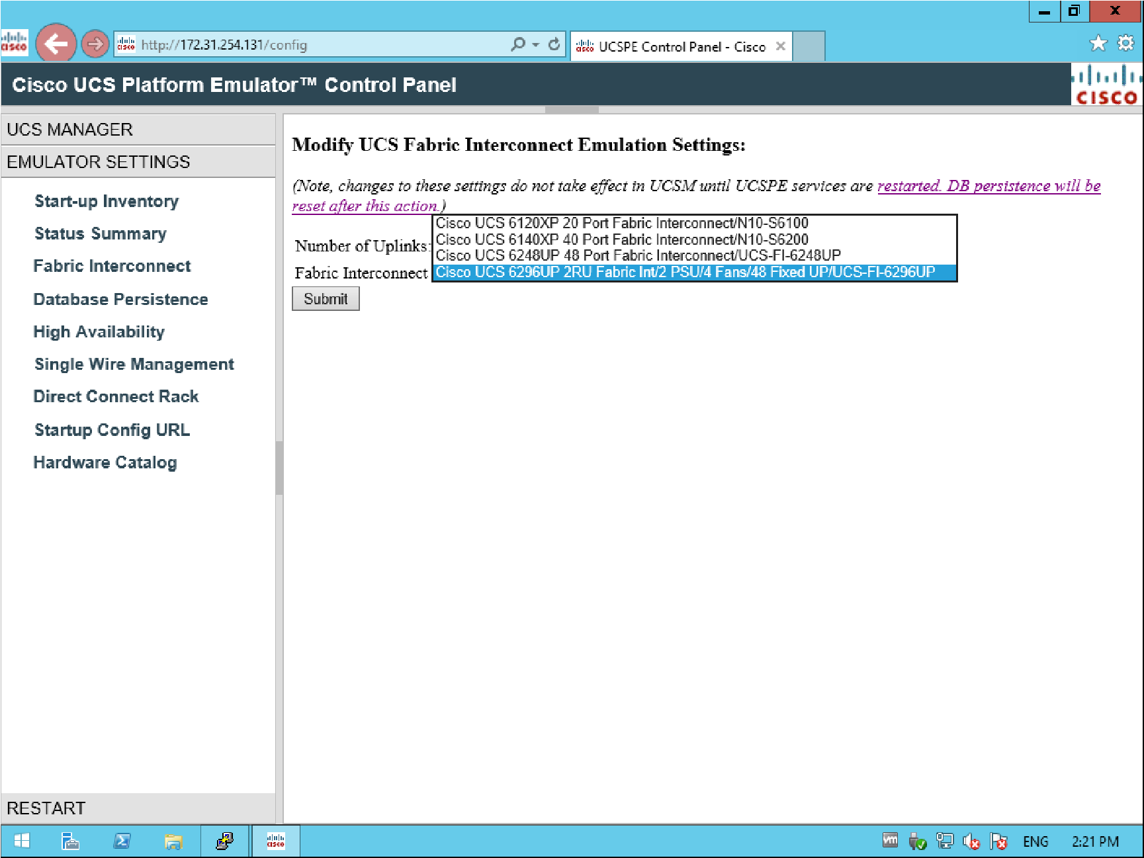

**UCS Database Persistence Settings**

From here you can choose to preserve or reset the DB upon restart.

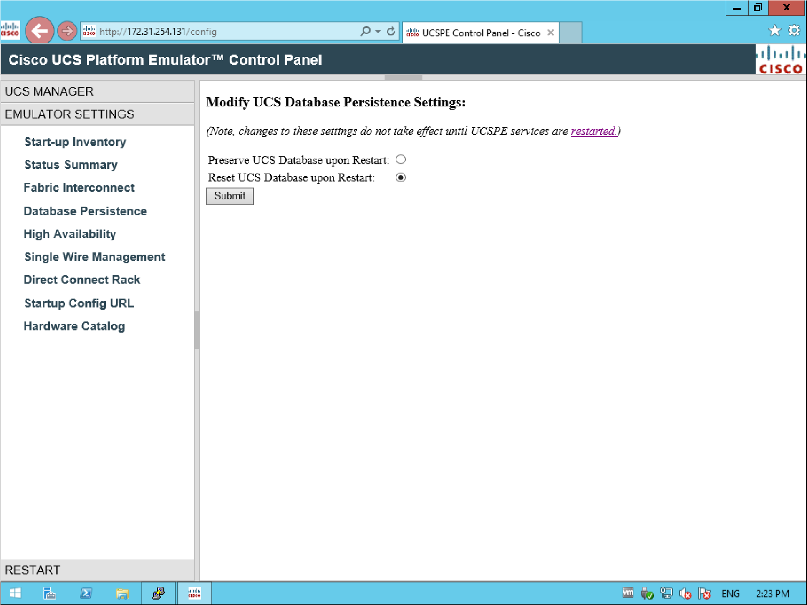

**High Availability**

You can configure High Availability options here. Note that the DB will need to be restarted after you apply the changes. Restart it and wait a little bit.

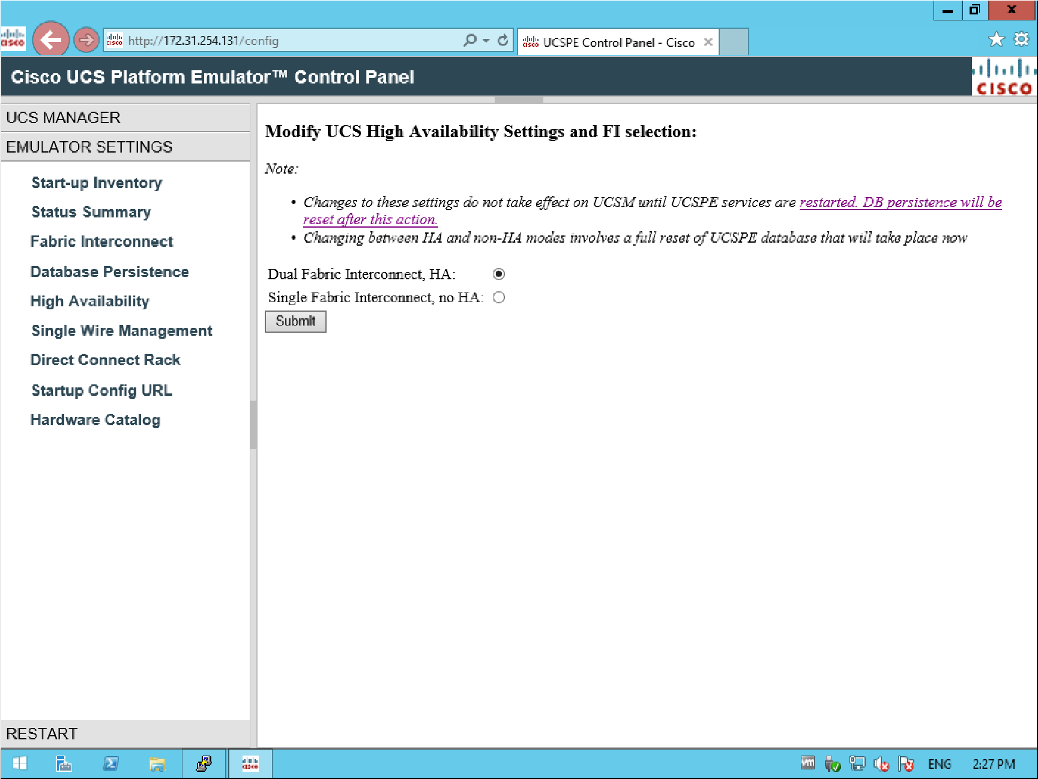

**Modify Single Wire Management Settings**

Looks like if you change any major configuration you always need to restart the DB.

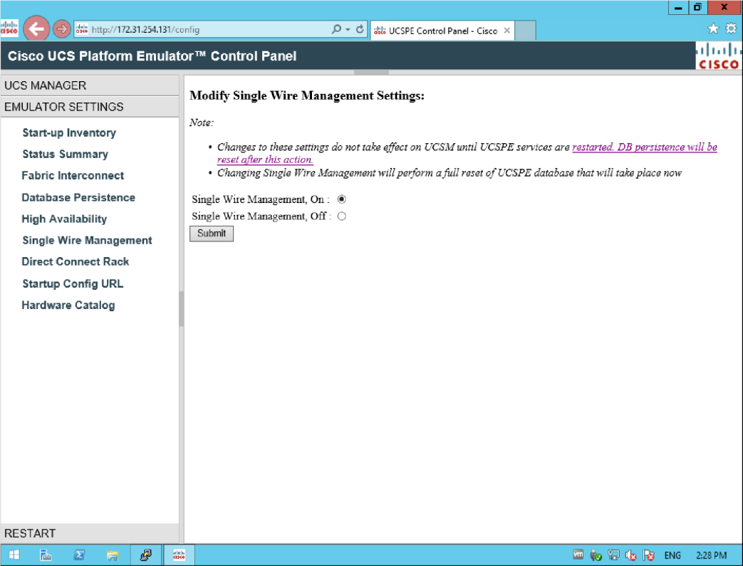

**Direct Connect Rack Settings**

Make sure you are careful not to lose any configuration during a lab operation. I can read that “Changes to these settings do not take effect on UCSM until UCSPE services are restarted” and the fact that the persistence DB will be reset after it, so be sure to read the basics.

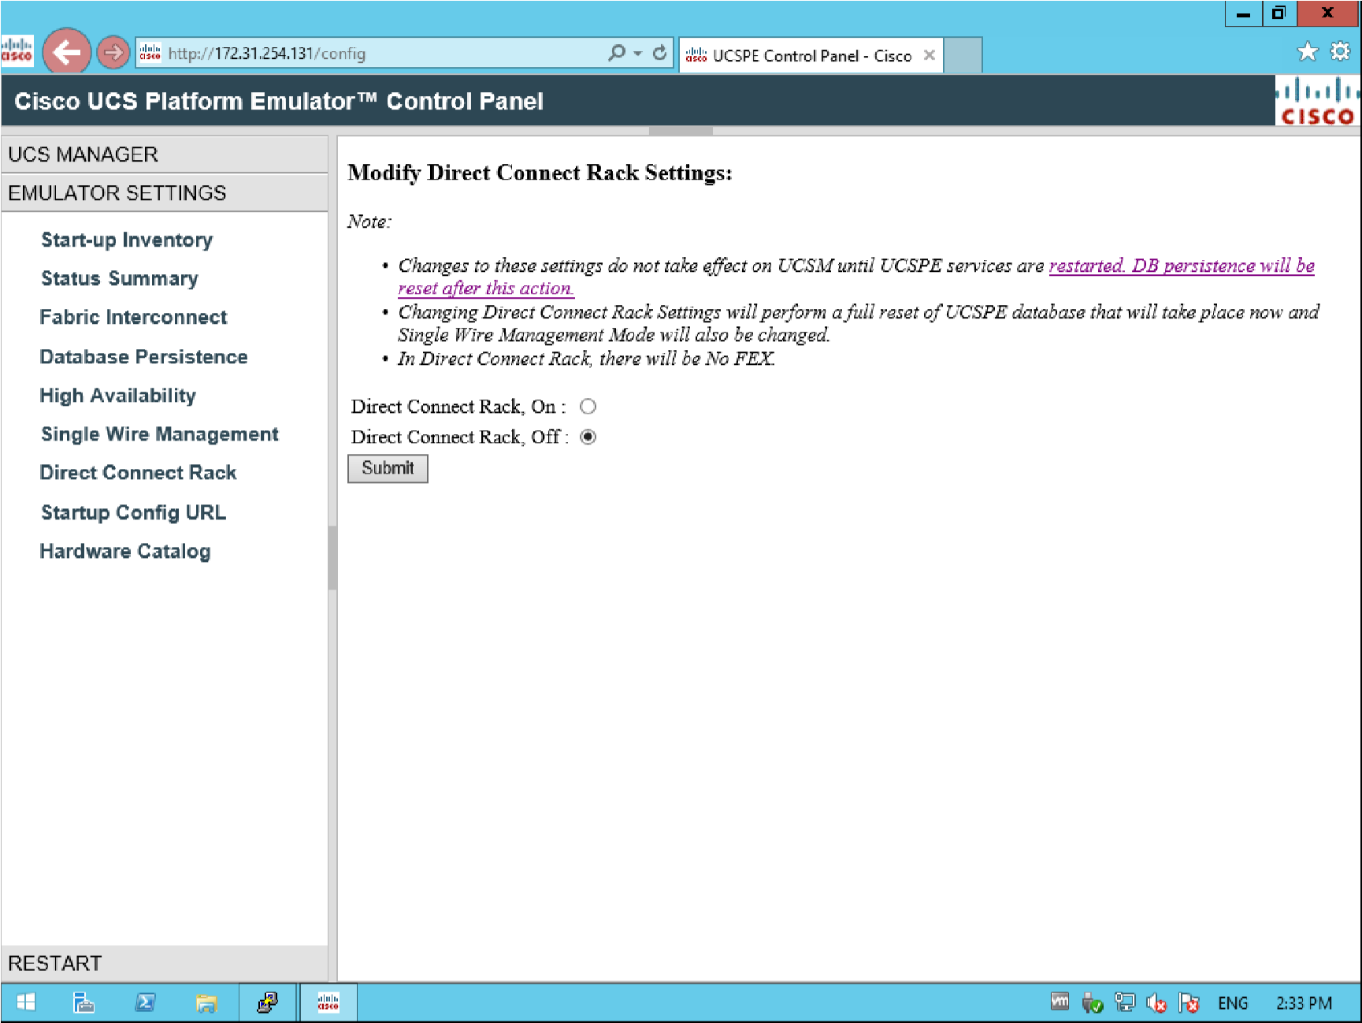

**Emulator Startup Configuration Source URL**

Pretty self-explanatory, you can have the startup-config URL changed. And backup configurations from URL (I presume). Looks cool. In my case that would be [http://172.31.254.131//hardware/startup/export](http://172.31.254.131/hardware/startup/export)

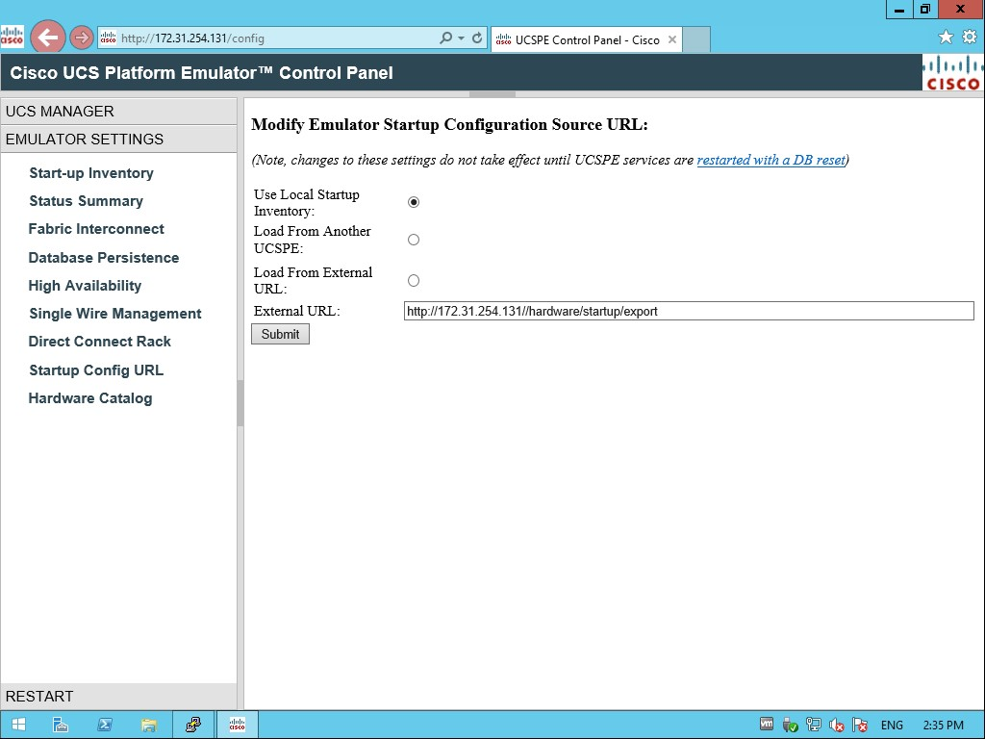

**Hardware Catalog**

From here you can buy Cisco hardware for the UCS. Pretty cool if you’re willing to invest. It is useful let me tell you!

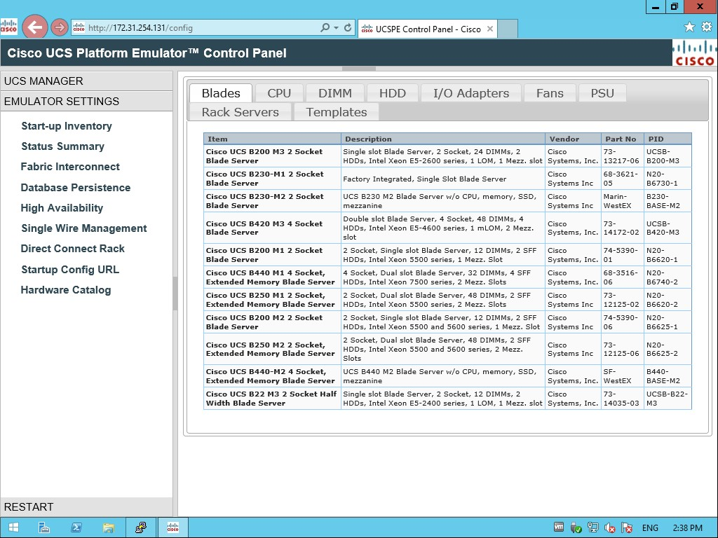

**UCS manager**

Let’s launch **UCS Manager**, please note that you need Java RE v1.6 or higher and Flash player installed! And yes, I’m serious!

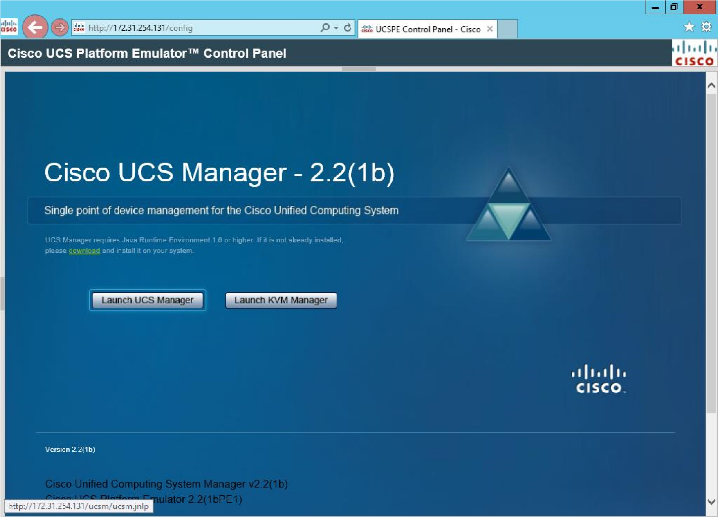

Now get used to the ugly and sluggish java applets and security warnings. Quite painful to see java and flash at the same time.

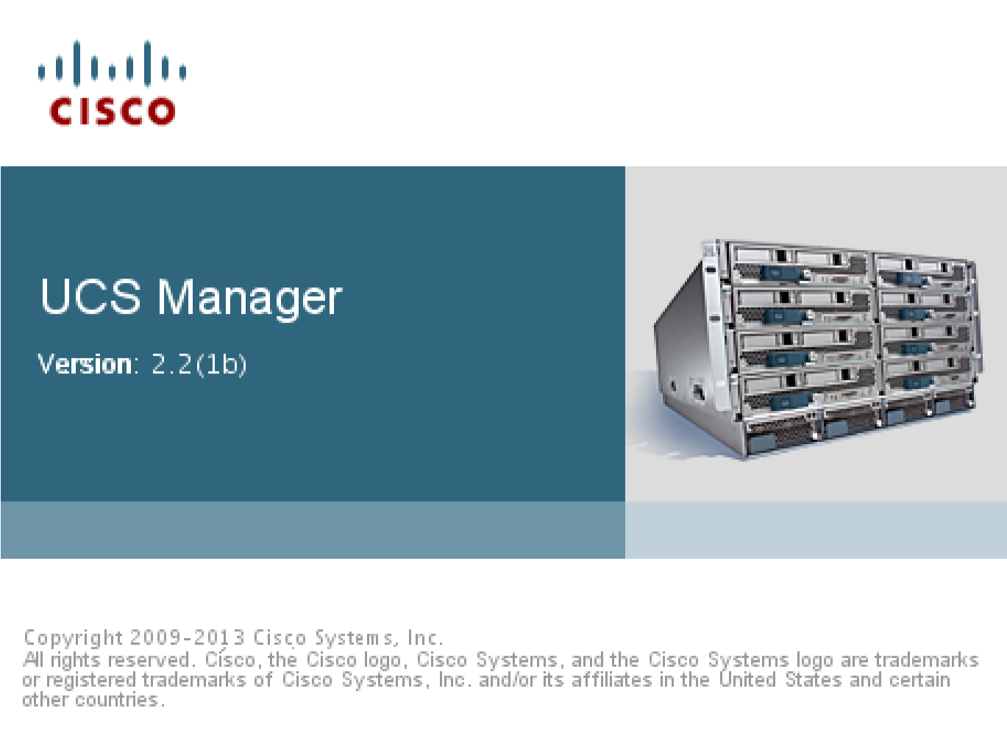

Kind of like ordering a pepperoni pizza and get a gum instead! Go figure…would love to see some html5 but super-fantastic anyway!!! Accept the warnings and wait for the UCS manager login.

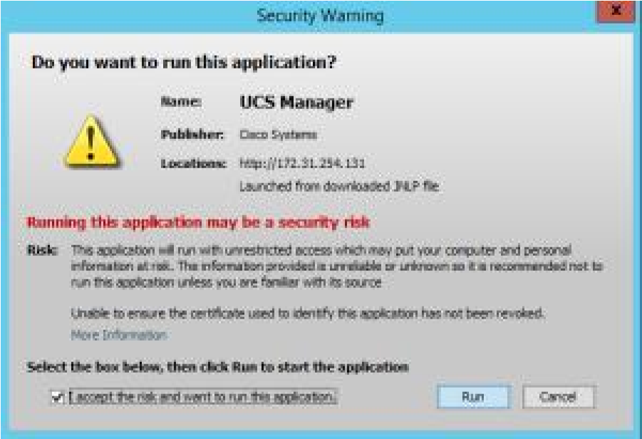

Login with username / password “**config**”

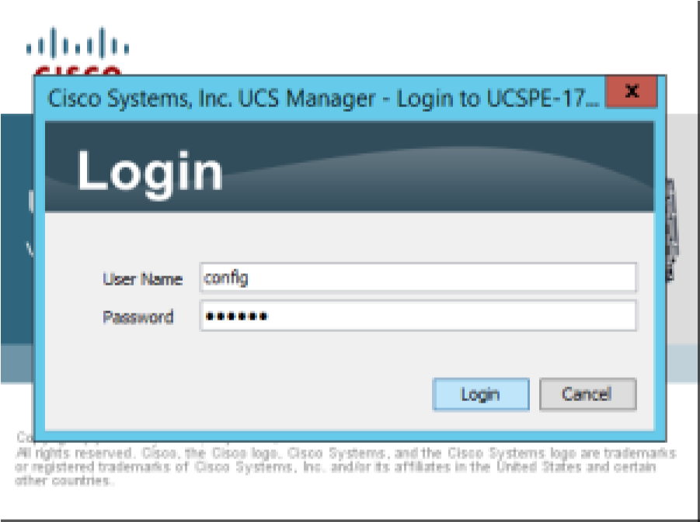

And here we are, Voila! UCS on my Labs!!! W00t!!! The sky is the limit!!! Just remembering that couple of years ago you wouldn’t even nother to know about UCS appliances now you have it on your laptop!

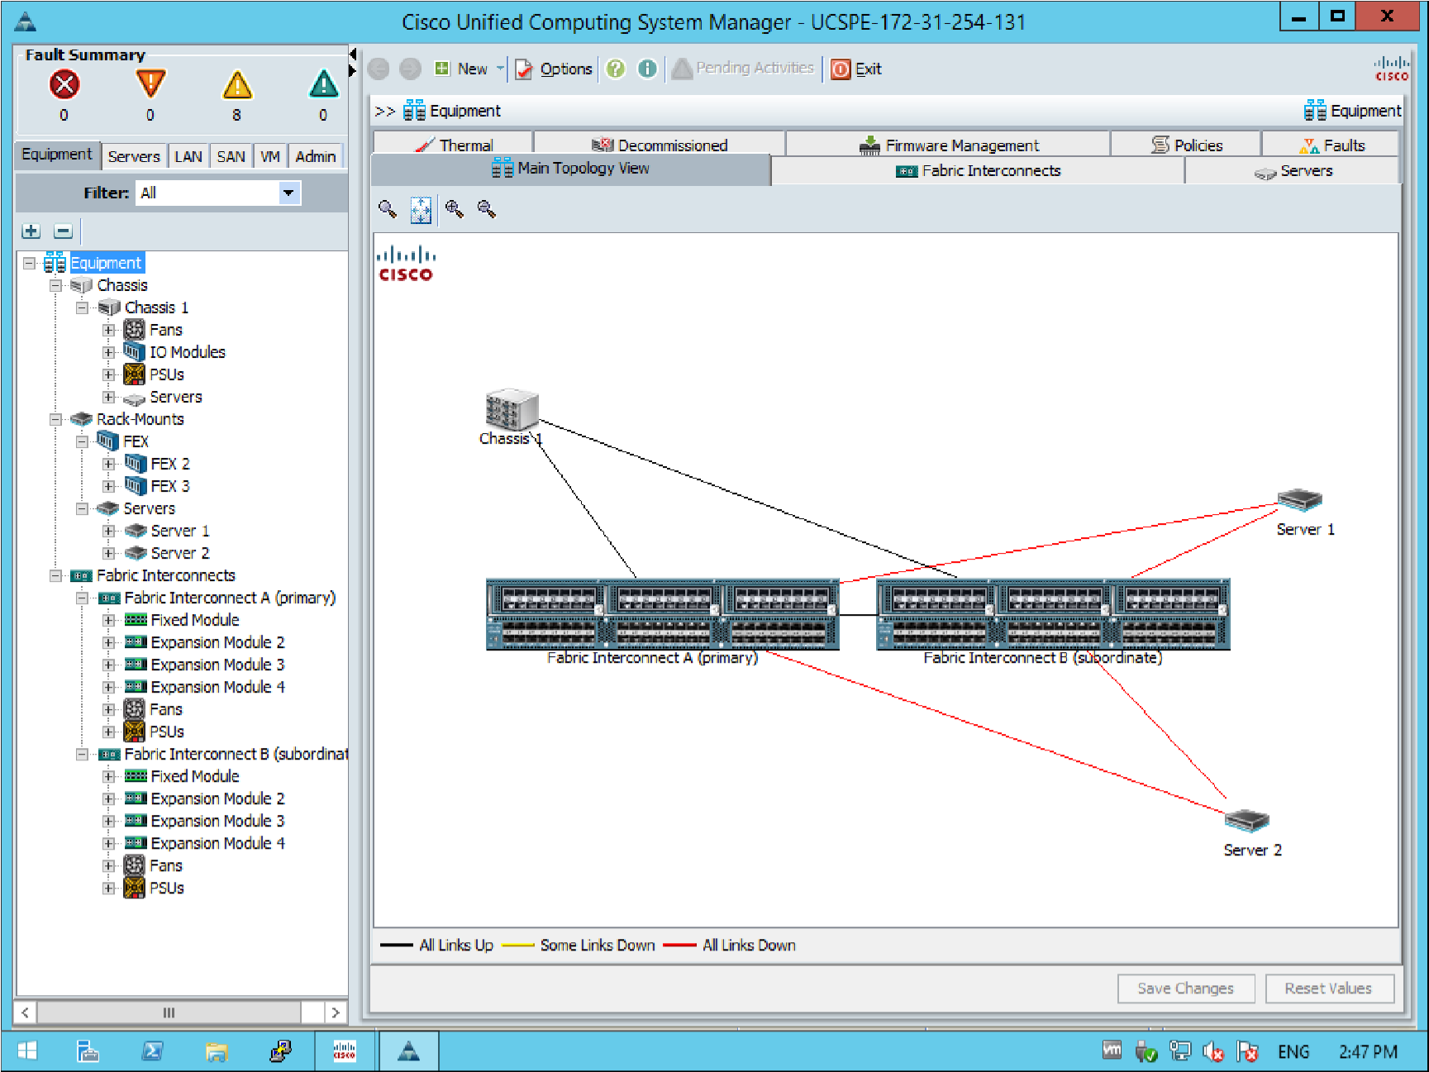

Let’s check the logs, looks like their starting to rain:

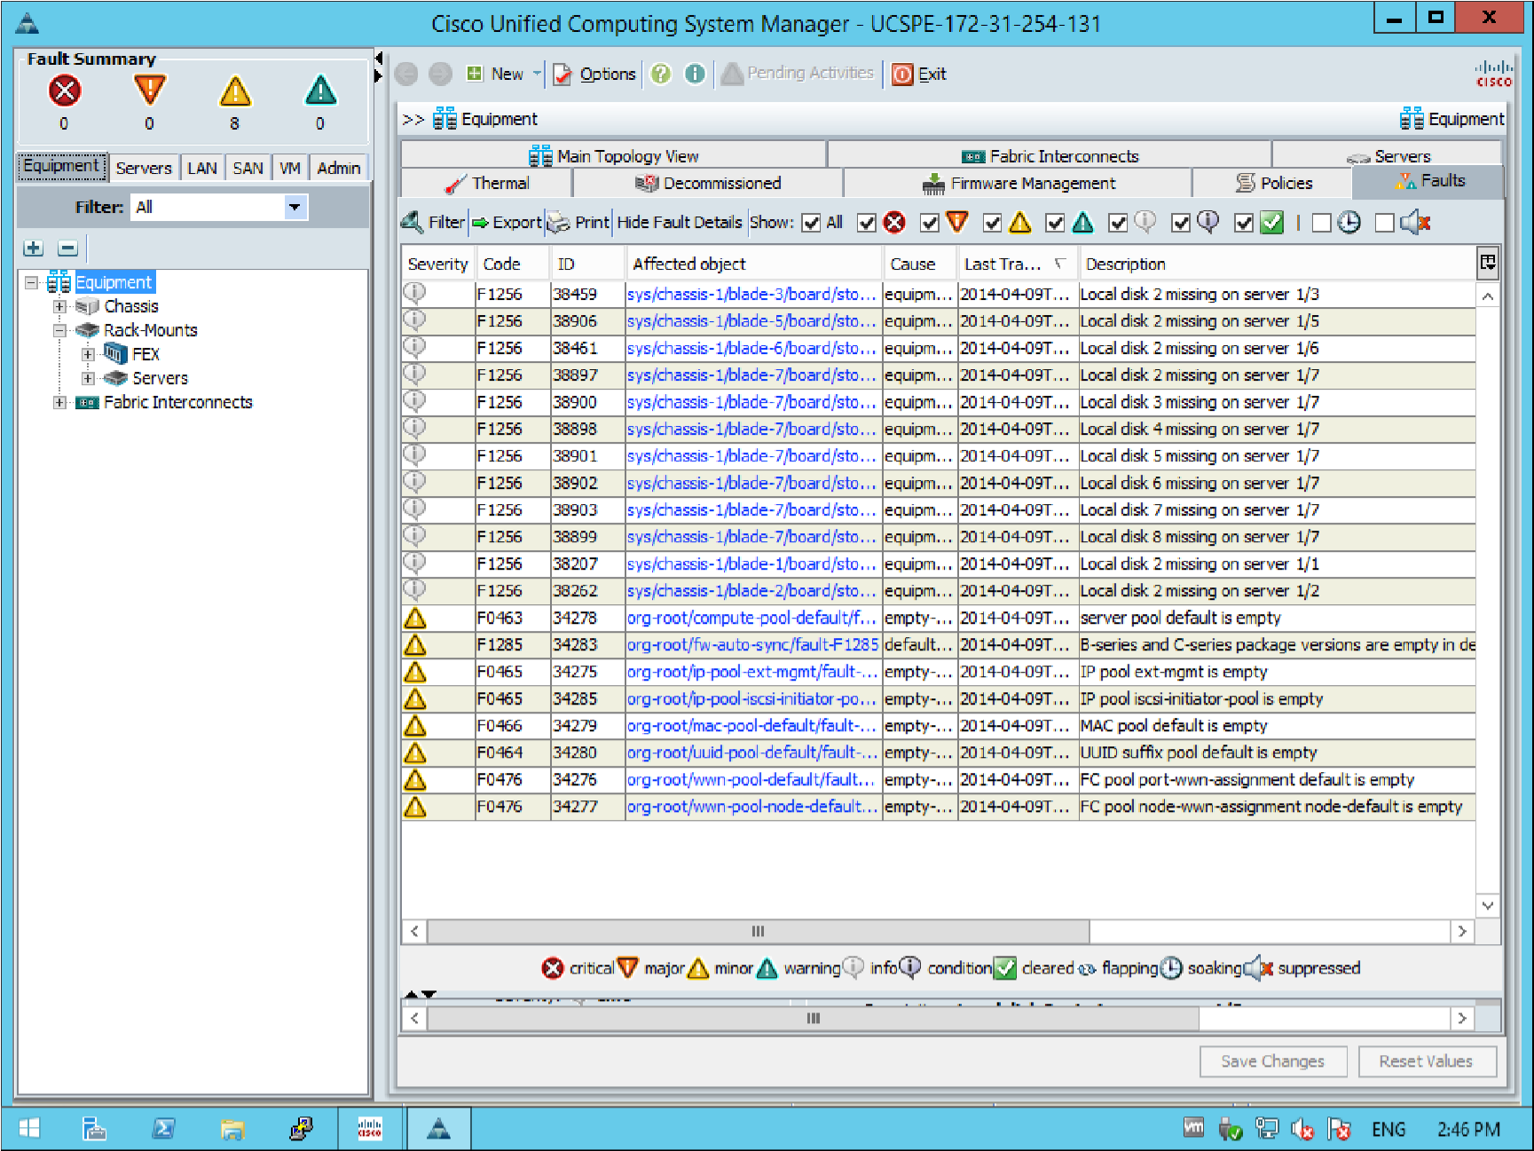

# Practical No 7

Implement vlan concept with L2/L3 switches/nexus virtual switching

**Layer 2 Access Switchports**

configure access VLAN assignments on SW1, SW2, SW3, and SW4 to obtain basic connectivity between the devices with Ethernet segments with the exception of R6.

SW1:

vlan 7,58,67,79,146

!

interface FastEthernet0/1

switchport access vlan 146

!

interface FastEthernet0/5

switchport access vlan 58

SW2:

vlan 8,22,43,58

!

interface FastEthernet0/2

switchport access vlan 22

!

interface FastEthernet0/4

switchport access vlan 43

!

interface FastEthernet0/24

switchport access vlan 22

SW3:

vlan 5,9,43,79

!

interface FastEthernet0/5

switchport access vlan 5

!

interface FastEthernet0/24

switchport access vlan 43

SW4:

vlan 10,146

!

interface FastEthernet0/4

switchport access vlan 146

**Layer 2 Dynamic Switchports**

Configure all inter-switch links on SW2, SW3, and SW4 to be in dynamic

auto state.

Configure all inter-switch links on SW1 to be in dynamic desirable state.

Using the CAM table verify that all layer 2 traffic between devices in the

same VLAN, but not attached to the same switch, is transiting SW1.

SW1:

interface range FastEthernet0/13 - 21

switchport mode dynamic desirable

SW2:

interface range FastEthernet0/13 - 21

switchport mode dynamic auto

SW3:

interface range FastEthernet0/13 - 21

switchport mode dynamic auto

SW4:

interface range FastEthernet0/13 - 21

switchport mode dynamic auto

**Layer 2 EtherChannel**

Remove all previous configurations on the links connecting SW1, SW2,

SW3, and SW4.

Configure all inter-switch links on SW2, SW3, and SW4 to be in dynamic

auto state.

Configure all inter-switch links on SW1 to be in dynamic desirable state.

Configure Layer 2 EtherChannels on all inter-switch links between SW1 &

SW2, SW1 & SW3, and SW1 & SW4.

Use Port-Channel numbers 12, 13, and 14 respectively.

These links should not use dynamic EtherChannel negotiation.

***Configuration***

SW1:

interface FastEthernet0/13

switchport mode dynamic desirable

channel-group 12 mode on

!

interface FastEthernet0/14

switchport mode dynamic desirable

channel-group 12 mode on

!

interface FastEthernet0/15

switchport mode dynamic desirable

channel-group 12 mode on

!

interface FastEthernet0/16

switchport mode dynamic desirable

channel-group 13 mode on

!

interface FastEthernet0/17

switchport mode dynamic desirable

channel-group 13 mode on

!

interface FastEthernet0/18

switchport mode dynamic desirable

channel-group 13 mode on

!

interface FastEthernet0/19

switchport mode dynamic desirable

channel-group 14 mode on

!

interface FastEthernet0/20

switchport mode dynamic desirable

channel-group 14 mode on

!

interface FastEthernet0/21

switchport mode dynamic desirable

channel-group 14 mode on

SW2:

interface FastEthernet0/13

channel-group 12 mode on

!

interface FastEthernet0/14

channel-group 12 mode on

!

interface FastEthernet0/15

channel-group 12 mode on

SW3:

interface FastEthernet0/13

channel-group 13 mode on

!

interface FastEthernet0/14

channel-group 13 mode on

!

interface FastEthernet0/15

channel-group 13 mode on

SW4:

interface FastEthernet0/13

channel-group 14 mode on

!

interface FastEthernet0/14

channel-group 14 mode on

!

interface FastEthernet0/15

channel-group 14 mode on

In this activity, you will use the Lab Topology and devices to explore Cisco UCS hardware,

examine connectivity and implement management hierarchy.

After completing this activity, you will be able to meet these objectives:

Launch and log into Cisco UCS Manager GUI

Use Cisco UCS Manager GUI

Identify and verify Cisco UCS hardware components

Identify and verify Cisco UCS internal connectivity

Identify and verify Cisco UCS LAN connectivity

Identify and verify Cisco UCS SAN connectivity

Identify and verify predefined UCS management hierarchy - organizations and locales

Identify and verify predefined user accounts, roles, and privileges – Role Based Access

Control (RBAC)

Create and verify organizations in Cisco UCS

# Practical No 8

**Simulating SAN with navisphere/netapps**

1. Analyzing the number of I/Os generated at peak workload

2. Documenting the application I/O size or block size

Consider an example of a SCSI controller (SCSI interface) with a throughput of

160 MB/s and disk service time RS = 0.3 ms. The computation of the rate

(1 / [RS +Transfer time]) at which I/Os are serviced in a typical database I/O with block sizes

4 KB, 8 KB, 16 KB, 32 KB, and 64 KB are shown in Table 2-1. The rate at which

the application I/Os are serviced is termed I/Os per second (IOPS).



As a result, the number of IOPS per controller depends on the I/O block size

and ranges from 1,400 (for 64 KB) to 3,100 (for 4 KB).

The disk service time (RS) is a key measure of disk performance; RS along with

disk utilization rate (U) determines the I/O response time for applications.

As shown earlier in this chapter, the total disk service time (RS) is the sum of

seek time (E), rotational latency (L), and the internal transfer time (X):

RS = E + L + X

E is determined based on the randomness of the I/O request. L and X are measures

provided by disk vendors as technical specifications of the disk. Consider

an example with the following specifications provided for a disk:

■■Average seek time of 5 ms in a random I/O environment, or E = 5 ms.

■■Disk rotation speed of 15,000 rpm — from which rotational latency (L)

can be determined, which is one half of the time taken for a full rotation

or L = (0.5 / 15,000 rpm expressed in ms).

■■40 MB/s internal data transfer rate, from which the internal transfer time

(X) is derived based on the block size of the I/O — for example, an I/O

with a block size of 32 KB or X = 32 KB / 40 MB.

Consequently, RS = 5 ms + (0.5 / 15,000) + 32 KB / 40 MB = 7.8 ms.

The maximum number of I/Os serviced per second or IOPS = 1/ RS.

In other words, for an I/O with a block size of 32 KB and RS = 7.8 ms, the

maximum IOPS will be 1 / (7.8 × 10-3) = 128 IOPS.

Table 2-2 lists the maximum IOPS that can be serviced for different block

sizes.



Table 2-2 shows that the value of E, the seek time, is still the largest component of RS. It contributes 5 ms out of 7.1 ms to 8.6 ms (58–70 percent) of the disk service time.

The IOPS ranging from 116 to 140 for different block sizes represents the IOPS that could be achieved at potentially very high levels of utilization (close to 100 percent). As shown in Section 2.4, the application response time, R, increases with an increase in utilization or the IOPS.

For the example in Table 2-2, the I/O response time (R) for an I/O with a block size of 64 KB will be approximately 215 ms when the controller works close to

96 percent utilization, as shown here:

R = RS / (1- U)

= 8.6 / (1-0.96)

= 215 ms

If an application demands a faster response time, then the utilization for the disks should be maintained below 70 percent, or the knee of the curve, after which the response time increases exponentially.

Considering another example from Table 2-2, with a block size of 8 KB and the utilization near 100 percent, a maximum of 139 IOPS could be achieved.

However, at U = 97 percent the IOPS in the system will be approximately 134, and the response time, R, for each I/O will be 240 ms.

Similarly, the response time for 105 IOPS (U = 75%) will be 29.5 ms; for 75

IOPS (54% utilization), it will be 15.7 ms; and for 45 IOPS (32% utilization), it will be 10.6 ms.

Considering a block size of 64 KB, at U = 100 percent, the maximum IOPS that can be sustained will be 116. The application will not be able to sustain 135 IOPS for the block size and performance specifications used in this example. For 64KB

I/O at 105 IOPS (U = 91%), R = 88.6 ms, and at 45 IOPS (U = 39%), R = 14.6 ms.

Storage requirements for an application are specified in terms of both capacity and the IOPS that should be met for the application. If an application needs

200GB of disk space, then this capacity could currently be provided with a single disk. However, if the application I/O demands are high, then it will result in performance degradation because one disk cannot provide the required response time for I/O operations.

The total number of disks required (N) for an application is computed as follows:

If *C* is the number of disks required to meet the capacity and *I* is the number of disks required for meeting IOPS, then

N = Max (C, I)

Disk vendors publish the disk potential in terms of IOPS based on the benchmark they carry out for different block sizes and application environments.

Consider an example in which the capacity requirements for an application are 1.46 TB. The peak workload generated by the application is estimated at

9,000 IOPS. The vendor specifies that a 146 GB, 15,000-rpm drive is capable of a maximum of 180 IOPS (U = 70%).

In this example, the number of disks required to meet the capacity requirements will be only 1.46 TB / 146 GB = 10 disks. To meet 9,000 IOPS, 50 disks will be required (9,000 / 180). As a result, the number of disks required to meet the application demand will be Max (10, 50) = 50 disks.

In many application environments, more disks are configured to meet the

IOPS requirements than to meet the storage capacity requirements. For response time-sensitive applications, the number of drives required is also calculated based on the IOPS that a single disk can sustain at less than 70 percent utilization level to provide a better response time.

**Application IOPS and RAID Configurations**

When deciding the number of disks required for an application, it is important to consider the impact of RAID based on IOPS generated by the application. The total disk load should be computed by considering the type of RAID configuration and the ratio of read compared to write from the host.

The following example illustrates the method of computing the disk load in different types of RAID.

Consider an application that generates 5,200 IOPS, with 60 percent of them being reads. The disk load in RAID 5 is calculated as follows:

RAID 5 disk load = 0.6 × 5,200 + **4** × (0.4 × 5,200) [because the write penalty for RAID 5 is 4]

= 3,120 + 4 × 2,080

= 3,120 + 8,320

= 11,440 IOPS

The disk load in RAID 1 is calculated as follows:

RAID 1 disk load = 0.6 × 5,200 + **2** × (0.4 × 5,200) [because every write manifests as two writes to the disks]

= 3,120 + 2 × 2,080

= 3,120 + 4,160

= 7,280 IOPS

The computer disk load determines the number of disks required for the application. If in this example an HDD with a specification of a maximum 180

IOPS for the application needs to be used, the number of disks required to meet the workload for the RAID configuration would be as follows:

■■RAID 5: 11,440 / 180 = 64 disks

■■RAID 1: 7,280 / 180 = 42 disks (approximated to the nearest even number)